**Cyber Security Gaming System**

By

First names & Surname

(Isheanesu Vunganai)

Cyber Security Gaming System Submitted in Partial Fulfillment of the

Requirements of the degree of

Bachelor of Technology

In

**Software Engineering**

In the

**School of Information Sciences and Technology**

Harare Institute of Technology

Zimbabwe



Supervisor

…………………………………………………………………..

Month/Year

May / 2023

**HIT 400 Project Documentation**



## Certificate of Declaration

This is to certify that work entitled “Cyber Security Gaming System “ *is submitted in partial fulfillment of the requirements for the award of Bachelor of Technology (Hons) in Software Engineering ,Harare Institute of Technology .It is further certified that no part of research has been submitted to any university for the award of any other degree .*

(Supervisor) Signature…………………………….. Date……………………….

(Mentor ) Signature…………………………….. Date………………………

(Chairman) Signature……………………………….. Date………………………..

## ABSTRACT

Cyber Security Gaming System is a software system that allows a user to play educational game(s) about the cyberspace and at the same time act as a platform where users can submit a report of cyber-crime done to them or a colleague. It is also a system that spreads awareness of the cyberspace, cyber crime and cyber security through news and a calendar of future cyber security events.

## PREFACE

This project is going to promote awareness of the Cyber Space, Risks and Security. It describes steps and processes which were chosen and implemented to develop this system. The intended audience of this document is the Harare Institute of Technology. The cases described in this document and the research conducted in this document helps to describe the problem being solved by said system developed which implementation procedures implemented in this document.

## ACKNOWLEDGMENTS

Firstly, I would like to acknowledge God Almighty, for helping me in doing my project and writing my documentation and on all my project and school related resources from the commencement of my HIT 400 project.

I would like to thank the Ministry of ICT, Postal and Courier Services for giving me an opportunity to broaden my own view on the realities of this digital world. I would like to thank my work supervisors, my Mentor The Information Security Officer Mr H.S. Masendu and The Deputy Director of Cyber Security Mr. T. Gumindoga who inspired me to do a project on Cyber Security. Also great thanks to my school supervisors; our Class Supervisor Madam L. Amos and my project Supervisor Mr. W. Manjoro for the exceptional help and guidance they provided me every step oy the was during my HIT 400 Project.

## DEDICATION

To my family, the pillars of my strength and the foundation of my inspiration. I also want to dedicate this project to the Lord God Almighty who gave me the strength and courage to work on this project despite all and any challenges I faced.

***TABLE OF CONTENTS***

Certificate of Declaration I

ABSTRACT II

PREFACE III

ACKNOWLEDGMENTS IV

DEDICATION V

CHAPTER 1: INTRODUCTION 1

Background 1

Problem Statement 1

Aims and Objectives 2

Hypothesis 2

Justification 2

Proposed tools 3

Feasibility Study 3

• Technical, 3

• Economic, 4

• Operational 4

Project plan – Time plan 4

Gantt chart 5

CHAPTER 2: LITERATURE REVIEW 6

2.1. Introduction 6

2.2. Related work 6

2.3. Conclusion 7

CHAPTER 3: ANALYSIS 8

3.1. Information Gathering Tools 8

3.2. Description of System 8

3.3. UML Diagram for Existing System 8

3.4. Data Flow Diagram for the Existing System 9

3.5. Functional Requirements 10

3.6. Non Functional Requirements 10

3.7. Evaluation of Alternative System 10

3.8. User case diagrams 12

CHAPTER 4: DESIGN 13

4.1.Systems Diagram 13

4.1.1 UML Context Diagram 13

4.1.2. Data Flow Diagram for the New System 14

4.1.3. Activity Diagram for the New System 15

4.2. Architectural Design 15

4.2.1.Hardware 15

4.2.2. Networking 15

4.3. Database Design 16

4.3.1. ER Diagrams 16

4.3.2. Normalized Database 17

4.4. Program Design 18

4.4.1. Class Diagrams 18

4.4.2. Sequence DIAGRAMS 19

4.4.3. Package Diagrams 20

4.4.4. Pseudo-code/ Sample Code 20

4.5. Interface Design 28

4.5.1. Dashboard 28

4.5.2. Trending News 28

4.5.3. Calendar 29

4.5.4. Report Crime 29

4.5.5. Quiz 29

4.5.6. Cyber Chace 31

CHAPTER 5: IMPLEMENTATION AND TESTING 33

5.1. Sample Code 33

5.1.1. Dashboard 33

5.1.2. Trending News 34

5.1.5. Quiz 46

5.1.6. Cyber Chace 46

5.2. Software Testing 51

5.2.1. Unit Testing 51

5.2.3. Intergration 51

5.2.4. System Testing 51

5.2.6. Test Cases 52

5.3. •Installation & deployment, Maintenance 54

CHAPTER 6: CONCLUSIONS AND RECOMMENDATIONS 55

6.1. Results and Summary 55

6.2. Recommendations and Future Works 56

6.2.1. Recommendations 56

6.2.2. Challenges 56

6.2.3. Future works 56

BIBLIOGRAPHY: APPENDICES 57

7.1. APPENDIX A - Bibliography 57

7.1.1. References 57

7.2. APPENDIX B - User Manual Of Working System 57

Introduction 57

Prototype Overview 58

7.2.1. Dashboard 58

7.2.2. Trending News 58

7.2.3. Calendar 58

7.2.4. Report Crime 59

7.2.5. Quiz 59

7.2.6. Cyber Chase 60

Exiting the system 60

7.3. APPENDIX C - Sample Code 61

7.3.1. Dashboard 61

7.1.2. Trending News 62

7.1.4. Report Crime 68

7.1.6. Cyber Chace 77

7.4. APPENDIX D - Research Papers 81

*TABLE OF TABLES*

CHAPTER 1: INTRODUCTION 12

CHAPTER 2: LITERATURE REVIEW 17

CHAPTER 3: ANALYSIS 19

CHAPTER 4: DESIGN 23

CHAPTER 5: IMPLEMENTATION AND TESTING 43

*Unit Testing - Table 5.1* 62

*System Testing - Table 5.2* 64

5.3. •Installation & deployment, Maintenance 64

CHAPTER 6: CONCLUSIONS AND RECOMMENDATIONS 65

BIBLIOGRAPHY: APPENDICES 67

*TABLE OF DIAGRAMS*

CHAPTER 1: INTRODUCTION 1

*Fig 1.1 - Gantt Chart* 5

CHAPTER 2: LITERATURE REVIEW 6

CHAPTER 3: ANALYSIS 8

*Fig 3.1 - UML Diagram for existing System* 9

*Fig 3.2 - Data Flow Diagram for Existing System* 9

CHAPTER 4: DESIGN 13

*Fig 4.1 - Context Diagram of proposed system* 13

*Fig 4.2 - Level 1 DFD of proposed system* 14

*Fig 4.3 - Activity Diagram for the proposed system* 15

*Fig 4.4 - ER Diagram* 16

*Fig 4.5 - Normalized Database* 17

*Fig 4.6 - Class Diagrams* 18

*Fig 4.7 - Sequence Diagram* 19

*Fig 4.8 - Package Diagram* 20

*Fig 4.9 - Dashboard* 28

*Fig 4.10 - Trending News* 29

*Fig 4.11- Cyber Calendar* 29

*Fig 4.13 - Report Crime* 29

*Fig 4.14 - Quiz Menu* 30

*Fig 4.15 - Easy Quiz* 30

*Fig 4.16 - Hard Quiz* 31

*Fig 4.17 - Avatar* 31

*Fig 4.18 - Cyber Chase* 32

CHAPTER 5: IMPLEMENTATION AND TESTING 33

5.3. •Installation & deployment, Maintenance 54

CHAPTER 6: CONCLUSIONS AND RECOMMENDATIONS 55

BIBLIOGRAPHY: APPENDICES 57

*Fig 7.1 - Dashboard* 58

*Fig 7.2 - Trendind News* 58

*Fig 7.3 - Cyber Calendar* 59

*Fig 7.4 - Report Crime* 59

*Fig 7.5 - Easy Quiz* 60

*Fig 7.6 - Hard Quiz* 60

*Fig 7.7 - Cyber Chase* 61

# 

# CHAPTER 1: INTRODUCTION

## Background

Zimbabwe is a developing country that is still growing in terms of technology at a faster pace, but, the bigger the influence of technology, the bigger the Cyber Space, and the greater the Cyber Risk and Crime. Thus, the need for a Cyber Space Control measure. Cyber Security is an immediate online system that links cyber security reports to the authority that can help Zimbabwean people who are exposed to Cyber Crime but at the same time creating a fun learning experience for its users regardless of age. This platform allows people to air their Cyber Security ideas, experiences, and get education. There would be the latest news on Cyber Space, Cyber Crime, and Cyber Security. The idea is to educate and give Zimbabweans a platform to report cyber-crime and have their concerns heard and dealt with. Once the report is put up for the Cyber Security , it is then put under review with programmers to find the culprit and bring them to justice. Cyber Security system would also have Cyber Security Calendar and Previews of Cyber Security Events and Campaigns, both national and international.

The implementation of this gaming system will be expected to shine on what can be done to best educate and protect Zimbabweans from cyber risks that are thriving on the cyberspace and on their lack of knowledge. The Design and content of serious games affect learners’ potential to form knowledge, skills and Habitual patterns [1]. This system will be a way out for many Zimbabweans to be educated, protected and protect themselves on the cyberspace, as this system will work as a way for Zimbabweans to learn and at the same time have fun.

## Problem Statement

The problems faced by Zimbabweans are; the fast-paced growth of Cyber crime, especially Scams and Phishing, and the lack of knowledge about Cyber Space, Cyber Crime, and Cyber Security.

Zimbabwe has a lot of learned people and fast-growing technology but so is the growth and widespread of Cyber-crime. Zimbabweans have been mostly exposed to scams and phishing schemes due to their country’s economy, that cyber criminals have seen this as a chance to lure and entice Zimbabwe. Zimbabwean citizens also lack enough knowledge of Cyber Space and its risks to users. They do not have enough information on how to protect themselves and prevent cyber-criminals from taking advantage of them. The gap between the level at which technology is influencing Zimbabwe and the level at which Zimbabweans know how to protect themselves is only growing by the minute.

## Aims and Objectives

The goal of the project and main focused objectives of the Cyber Security system are;

To create two games that are fun and interesting in a way to educate Zimbabweans on the Cyberspace, its risks and securities. these games being:

* Quiz Game
* Cyber Chace

To have windows that promote awareness of the Cyber space, crime and security by:

* Showing recent news about the Cyberspace (Trending News)
* Showing recent and future Cyber Security events (Cyber Calender)

To provide a button to submit reports of cases of cyber-crimes to the Zimbabwe Republic Police.

## Hypothesis

Cyber Security Gaming System is a system that is expected to use games as an educational way to teach people and spread awareness of the Cyber Space, Risks and Security. These hypotheses reflect on how this system is expected to help reach the aims set up for it;

*‘People who play video games have mental health benefits.’* It is believed that improved memory, cognitive function and problem solving skills. It is in the best interest of the creation of this system to have the users learn about cyber security in a healthy way.

*‘Playing video games improves one’s curiosity and learning.’* When one plays video games, the brain is said to be working and growing as they work to figure out the game and complete puzzles to master a level, thus creating new connections in their minds. This acts as way of continued stimulation of the brain drawing it more to the subject being presented by the game. The goal for the development of this system is to spread awareness of and teach cyber security to civilians.

## Justification

Zimbabwean citizens also lack enough knowledge of Cyber Space and it’s a risks to users. They do not have enough information on how to protect themselves and prevent cyber-criminals from taking advantage of them. The gap between the level at which technology is influencing Zimbabwe and the level at which Zimbabweans know how to protect themselves is only growing by the minute.

Zimbabwe has a lot of learned people and fast-growing technology but so is the growth and widespread of Cyber-crime. Zimbabweans have been mostly exposed to scams and phishing schemes due to their country’s economy, that cyber criminals have seen this as a chance to lure and entice Zimbabwe.

During my internship period with the Ministry of ICT, postal and Courier Services, Cyber security Department; I got a chance to witness how Zimbabwe handles cyber space and how they react to the existence of cyber crime and cyber security. I saw a great gap in the way people know and handle themselves in the cyber space and the little knowledge they have of the cyber risks and securities. I want to teach, spread awareness and help people both who have and haven’t fallen prey to schemes online that disadvantage them but at the same time making their learning experience as fun and interesting as possible**.**

## Proposed tools

The ‘design and development’ stage for this system will be divided into two parts, the first will be the programming of the main dashboard system, which presents the news, calendar and report forms, and the game programs. Thus, because of these functionalities that are to be input into the system, both parts will be done in the C# programming language using Microsoft Visual Studio for the gaming environment. This will be possible to create because of the well able PC that will be used to create the system that is a Core i5 machine with a 2.6GHz processing power.

## Feasibility Study

### Technical,

This system will be a desktop application that will be developed using a Personal Computer / laptop that is a Core i5 machine with a 2.6GHz processing power, which is more than competent to handle the development of a video game. This system be available to all computers thus it would be accessible to anyone who has access to a desktop computer or a laptop. The fact that technology in Zimbabwe is spreading fast like wild fire in Zimbabwe such that even students from primary level to tertiary levels have access to technology especially desktop computers and laptops, this make it feasible for the accessibility of the system to be wide spread in Zimbabwe

### Economic,

The development o this system will require the attaining of equipment (computer), software application and/or environment for the system development (MSV) and labor. Tis system will e purely software and no need to purchase any hardware as ll the equipment needed is readily available and the software used are free as well as the labor as it is a one man job, thus this project will not be having costs tags on it for any purchases. However, when it is complete and launched, it is expected to bring cash inflows. For instance, if it is put on the market, for each download there is cash inflow, for any coin purchases on the game also results in cash inflow. This is from the gaming side, from the dashboard, for every click in the links on the news or events presented in the dashboard is also cash inflow.

Thus, this system is expected to require little to no investment into developing it but also expected to bring in revenue upon its launch.

### Operational

The problems Zimbabwe are the fast-paced growth of Cyber crime, especially Scams and Phishing, and the lack of knowledge about Cyber Space, Cyber Crime, and Cyber Security as the wide spread of technology grows in Zimbabwe. The Cyber Security Gaming system's operation ability will be easy and user friendly such that any person who can use a computer is able to understand. The features are self explanatory and direct meaning no delay in learning how to use it. It won’t rely solely on Internet connection for an individual to access it, but it will work offline, and online will be for purchases, latest news and other additional benefits. The games would provide levels of difficulty to pique the interest of the user, this is to have the user interested Cybersecurity enough to go further into the study.

## Project plan – Time plan

The proposed methodology for this system will be the waterfall software development process model, but the documentation will be done simultaneously with the programming to cater for the time constraint and any modifications that may apply to the developing system.

## Gantt chart



*Fig 1.1 - Gantt Chart*

The time table for the project is expected to be done as illustrated by fig 1.1. It was decided by the developer to tackle the project in a fashion that allowed to work on the prototype hand in hand with the documentation dividing the whole process into three phases; Concept Implementation and Closing Phases. That way it would be easier to create a system that would be easier to understand as it goes hand in hand with the documentation.

# CHAPTER 2: LITERATURE REVIEW

## 2.1. Introduction

In relationship with this project many researches were carried out earlier, and a web based and desktop applications have been made specially to cater for the use of serious games to educate people especially students and employees internationally. This has been successful but in the case of Zimbabwe, such practice has not been widely explored. Many incidents of cybercrime have been happening every day in Zimbabwe, with many victims fallen to the traps because of lack of knowledge and immediate support, this project is going reduce the consequences of those situations allowing effective cyber security education together with trendy news to keep citizens up to date with new tactics that cyber criminals are coming up with to fool them.

## 2.2. Related work

The paper on ‘Comparing Serious Games for Cyber Security Education” expressed the use of gaming as a way of education that can be used even for government institutions, big organizations and learning constitutions. It made a note of how cyber security games contributed to the spread of awareness in a more captivating way through gaming by comparing a set of games and their quality educational tactics. The concept of serious games for cyber security awareness initially was one part of a broader awareness campaign led by governments, corporations, cyber education organizations to teach basic information assurance concepts such as: confidentiality, authentication, integrity, and availability to informal learners (people with no prior knowledge or limited knowledge).[1]

The second research paper was the enhancement of classroom learning experiences using gaming and how it is a better way for learning as it demands more interaction with a user and at the same time teaching in a fun way. According to research, using games in teaching can help increase student participation, foster social and emotional learning, and motivate students to take risks. One study of the popular multiple-choice quiz game Kahoot found that it improved students' attitudes toward learning and boosted their academic scores [2]

The research on the Cyber Security trends highlighted the growth and spread of malice on the Cyberspace has been contributed by the lack of awareness and poor practices by people globally .That is because organizations continue to lack cyber security awareness and utilize poor practices that result in their data being unprotected and vulnerable to theft and breaches[3]. Research also showed that with the lack of knowledge towards cyber security people have globally, there have been more attacks being reported, from the past years up until now from a smaller scale (individual) to greater scales (governments, organizations). The following are examples of attacks that have been recently reported on a global scale.

*‘2022 – The ZLoader botnet responsible for distributing the ZLoader malware was taken down in a joint effort with Microsoft, ESET, Black Lotus Labs, Palo Alto Networks, HealthISAC, and Financial Services-ISAC.*

*2022 – On May 8th, 2022 the national emergency was declared due to an ongoing Conti ransom ware attack against several Costa Rican government entities.*

*2021 – Saudi Aramco experienced a data breach exposing sensitive data on employees and technical specifications of the organization. Threat group ZeroX is demanding a payment of $50 million'[4]*

From the presented researches, Zimbabwe seems to be a great risk of cyber-attacks and a system like Cyber Security Gaming system, it would be an effective way forward to teach people on cyber security in an efficient way like mini serious games and at the same time giving them a platform that allows citizens to report cases of cybercrime they encounter.

## 2.3. Conclusion

From the previous researches the use of ‘serious’ games has been used for dealing with immediate education in schools and work environments so to help students and employees learn faster and easier the desired concepts. The problem we seek to solve comes as a result of poor use of technology and lack of knowledge in the cyber security sector which is lagging behind. In accordance to the improvements Cyber Security Gaming System is going to be the best application for immediate help and educational insight.

# CHAPTER 3: ANALYSIS

## 3.1. Information Gathering Tools

The analysis of this system is the process of gathering information, this being the solution to the problem and the decision over all constitution of this desired system. In system analysis, analysis of all the process related features, the required functions, the available sources and time that should be specified at the analysis stage. A system analysis's broad outline would decide how the problem in the world can be related to a machine, thus referred to as the examination of the problem. It is concerned with identifying the constraints and influences. Requirement gathering, specification and planning are essential parts of this project and project management that are going to be acquired through the use of the following tools;

* Computers - for data capture and system development
* Interviews - For information and requirement gathering
* Questionnaires - For information and requirement gathering
* Revision of Literature
* Internet sources e.g. YouTube and browsers.

## 3.2. Description of System

Cyber Security Gaming System is a desktop system which work on both offline and online the internet network services on any desktop platform e.g. desktop computer, Laptop etc. The user installs the Application and can traverse through the application. The application has two main regions where the user can access the data. These fields include the Dashboard and Game Arcade;

The Dashboard is the section responsible with the spreading of awareness and reporting cyber-crime; it has the news board, calendar and Report Form. This offers a great way to keep up to the new trends in Cyber Security, have an easier way to report a cyber-crime from the comfort of one’s own home and keep up with the cyber events on the cyber security-based calender.

The Game Arcade were there are two games, the Cyber Chace and the quiz game. The Cyber chace game is of a character who has to avoid cyberspace harzards while running, e.g a ‘black hat hacker’. The Quiz Game is about answering a series of questions with a chance of unlocking brand new avatars. Both games make the learning experience much easier and fun.

Once done with the application the user can easily exit the system.

3.3. UML Diagram for Existing System

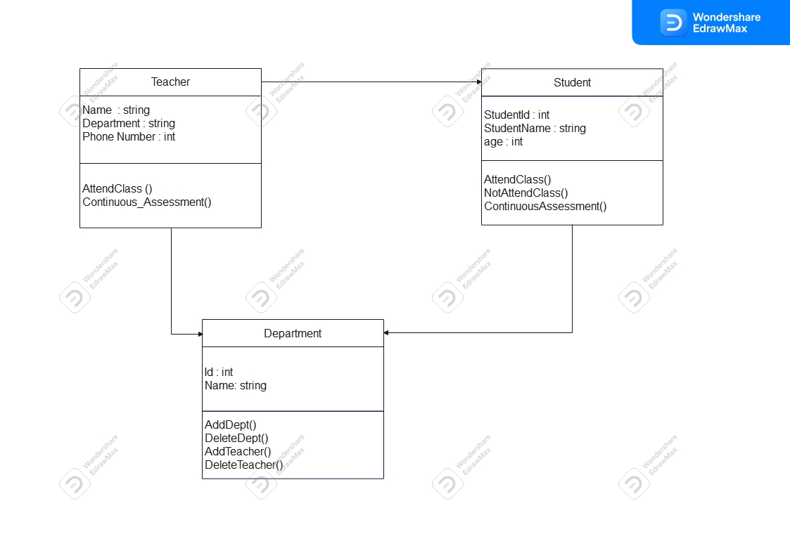

###### *Fig 3.1 - UML Diagram for existing System*

The most common system that works as the proposed system is the classroom system. As shown by fig3.1, the teacher, student and department are the major entities that are involved in ths system. The teacher give Student work and teaches student, and belongs to a department. The student gets data from the teacher and also belongs to a department, e.g. software engineering department.

3.4. Data Flow Diagram for the Existing System

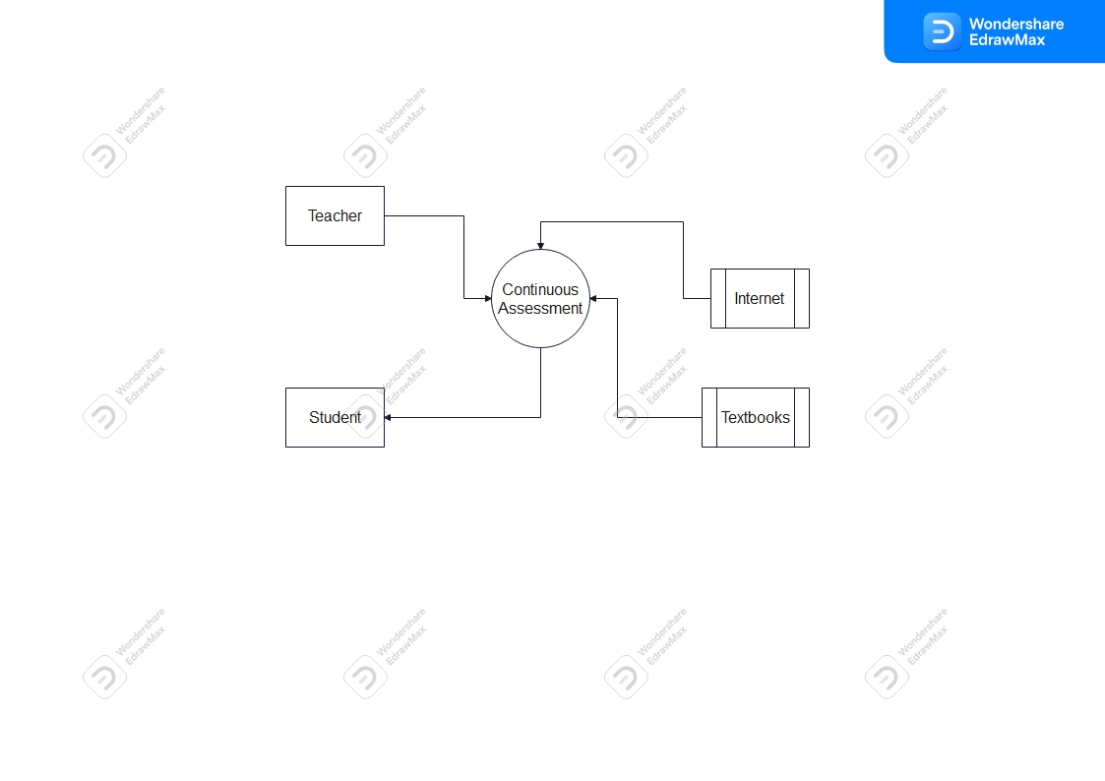

###### *Fig 3.2 - Data Flow Diagram for Existing System*

The system relies on continuous assessment for the teaching and learning of the teacher and student respectively, using internet and textbooks as the data sources as fig 3.2 illustrates.

3.5. Functional Requirements

The functional requirements of this system are features that must be implemented to enable a user to achieve their goals in the system. These define the basic system behavior of the Cyber Security Gaming System and describe what the system is expected to do. The following functional Requirements of the system will describe particular behaviors and/or functions of this system when certain conditions are met.

* Only the administrator and development team to alter the contents of the database.
* The user must search for the required activity
* The system gives information about cyber security
* It also gives trending cyber security news,
* The user must be able to interact with the game characters that familiarize them with cyber security
* Provides victims of cyber-crime with the information about the trendiest cyber security news available both nationally and internationally.

## 3.6. Non Functional Requirements

The non-functional requirements of this system are global constraints that specify how this system is expected to behave and define the limits on its functionality. These non-functional requirements cover the remaining requirements which are not covered by the identified functional requirements above. They will specify the criteria which judge the operation of the Cyber Security Gaming System, rather than specific behaviors.

* this system is going to accommodate a million number of users.
* It is target the nation as a whole and free for everyone
* The application can be accessed by any device as long as it is a desktop computer or a laptop.
* The system can be extended and modified to cater for evolution.

## 3.7. Evaluation of Alternative System

From previous research, the alternative systems in Zimbabwe was the use of the educational systems of a teacher teaching a student or through exhibitions at events and campaigns.

This system of manual presentation is inferior to the automation of the educational system because it has many limitations for example it is dependent of the availability of either the teacher and student. This limitation slows down the learning and limited to the education of the enrolled personnel alone when our goal is to spread the awareness across the country

3.8. User case diagrams

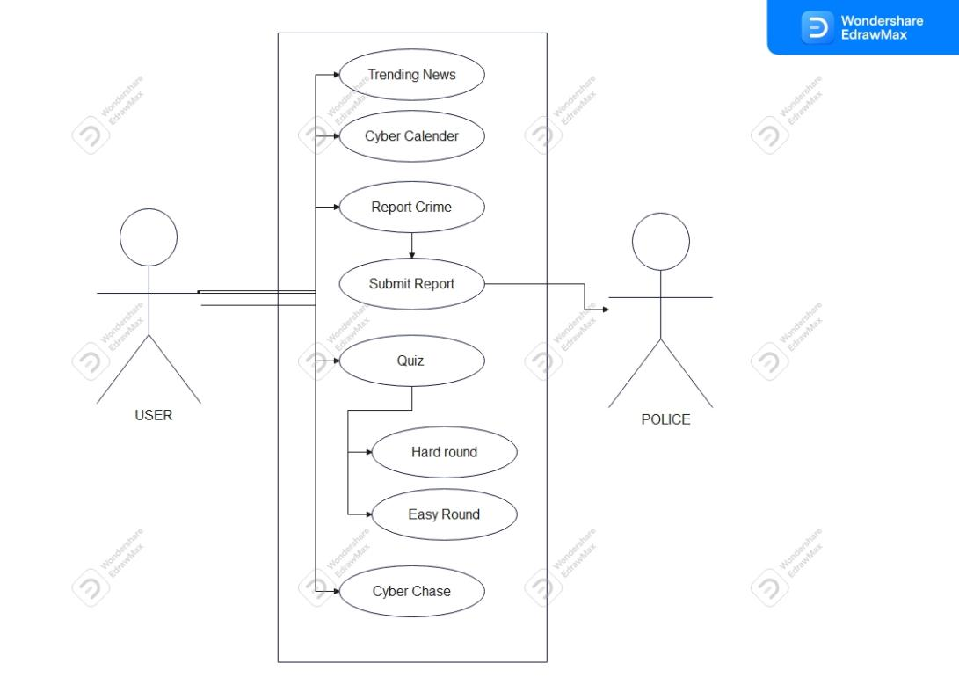

*Fig 3.3 -*

# CHAPTER 4: DESIGN

## 4.1.Systems Diagram

### 4.1.1 UML Context Diagram

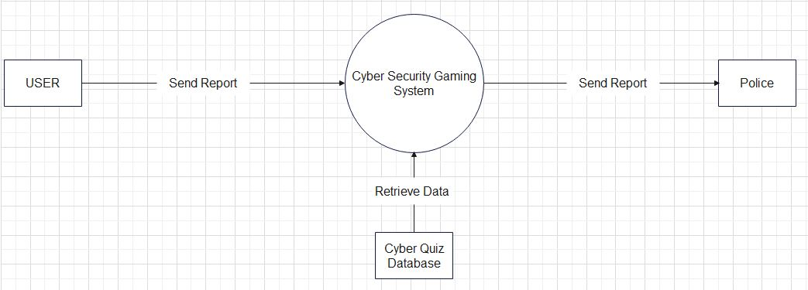

###### *Fig 4.1 - Context Diagram of proposed system*

This is the level 0 Data Flow Diagram of the Proposed Diagram of the Proposed System

4.1.2. Data Flow Diagram for the New System

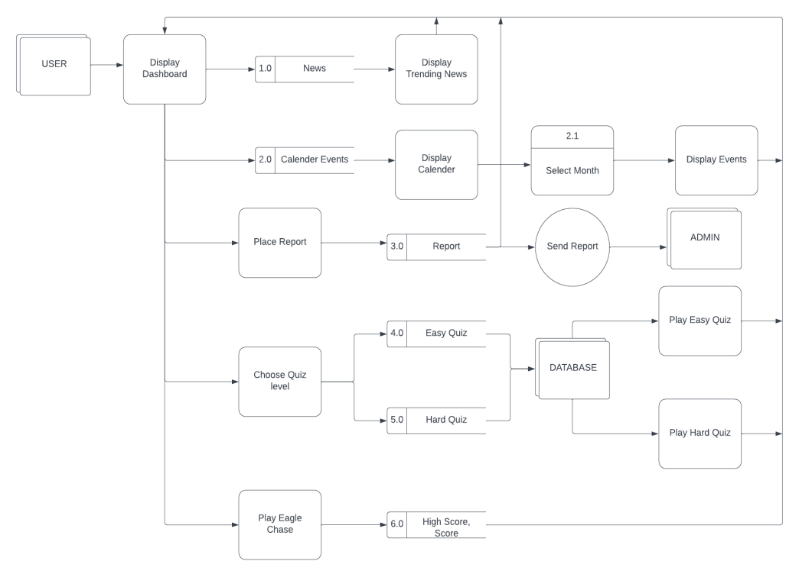

###### *Fig 4.2 - Level 1 DFD of proposed system*

This is the level 1 Data Flow Diagram of the proposed System

4.1.3. Activity Diagram for the New System

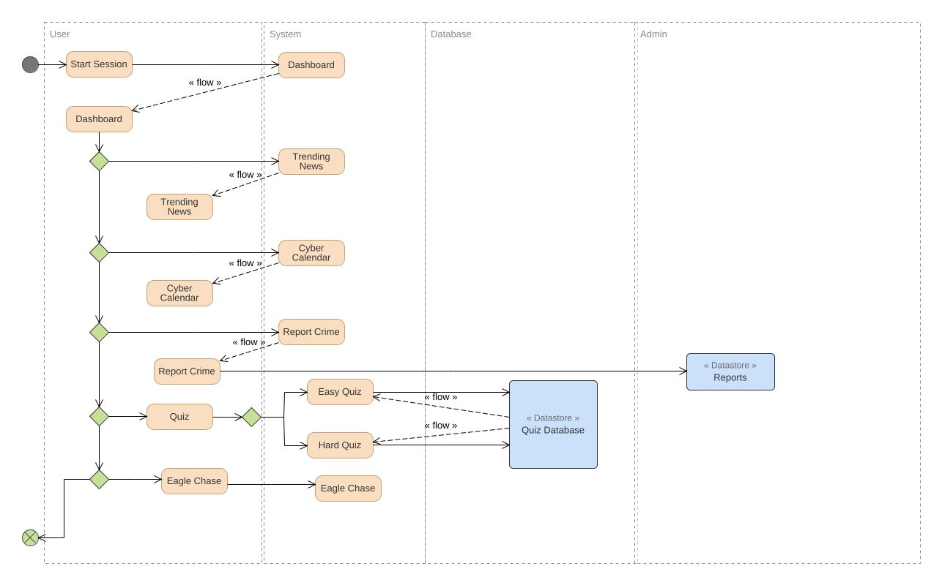

###### *Fig 4.3 - Activity Diagram for the proposed system*

This is the activity diagram that shows the relationship between the components in the system and the navigation that the user can do in the system.

4.2. Architectural Design

### 4.2.1.Hardware

To implement the Cyber Security Gaming System a user will need a desktop computer or Laptop. The software will be hosted on a game server and from anywhere this software is downloadable via internet and accessible offline.

### 4.2.2. Networking

The Cyber Security Gaming System is an offline-based system and consists of single-player games with game data stored in a database thus networking is not typically expected in the games to a database, as both games do not require communication between players or with a central server. This is best for handling offline play, since the player can gracefully return to an offline state when network connectivity is lost without any disturbance.

However, For the Dashboard, where there is the Report to be submitted, networking is required to send a document from the to another computer over the internet. File transfer would be used to copy or move the file from the user’s computer to the police email over the internet connection. To send the report, the user’s computer must be able to connect to the internet. The report would be transferred using the file transfer protocol, such as FTP or HTTP, or by sharing the file to any Windows application that supports services like OneDrive or Google Drive.

4.3. Database Design

### 4.3.1. ER Diagrams

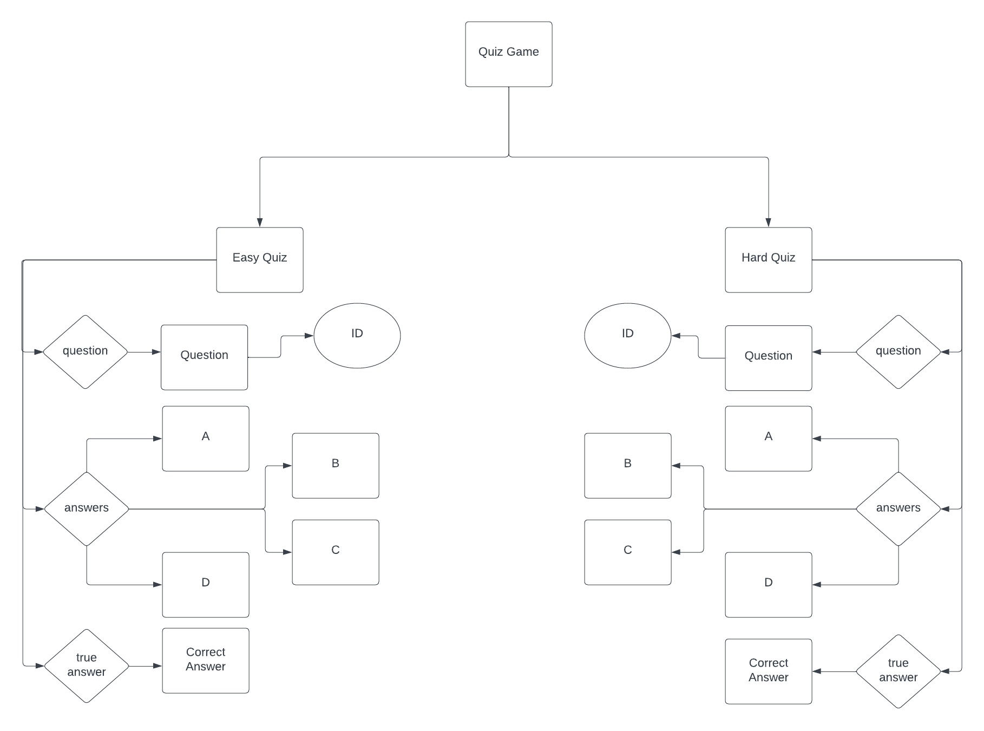

###### *Fig 4.4 - ER Diagram*

4.3.2. Normalized Database

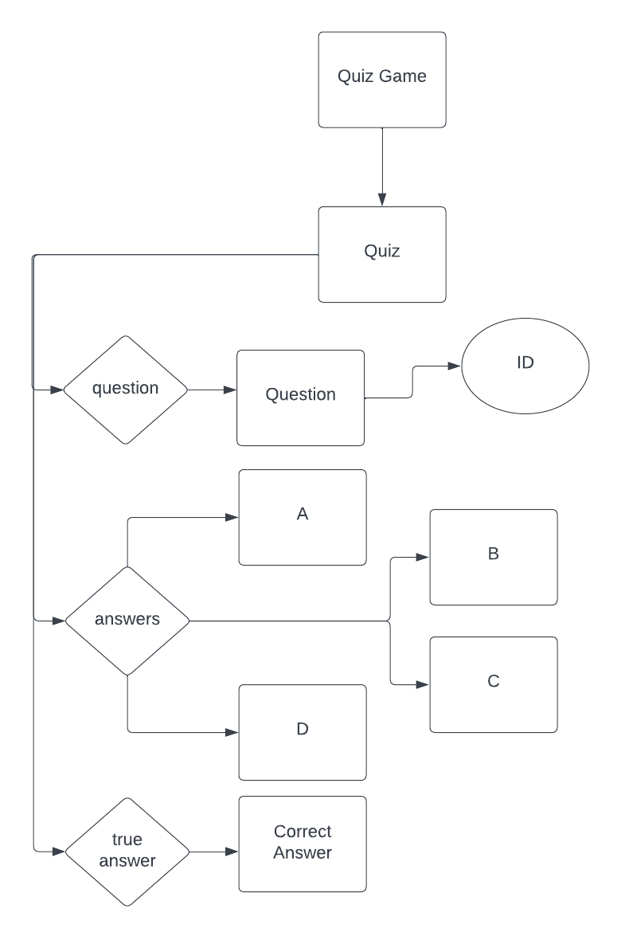

###### *Fig 4.5 - Normalized Database*

4.4. Program Design

### 4.4.1. Class Diagrams

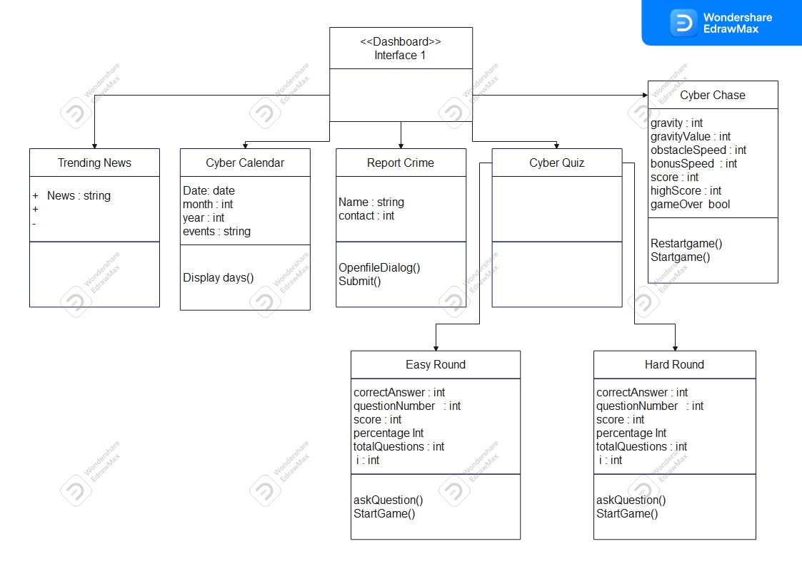

###### *Fig 4.6 - Class Diagrams*

4.4.2. Sequence DIAGRAMS

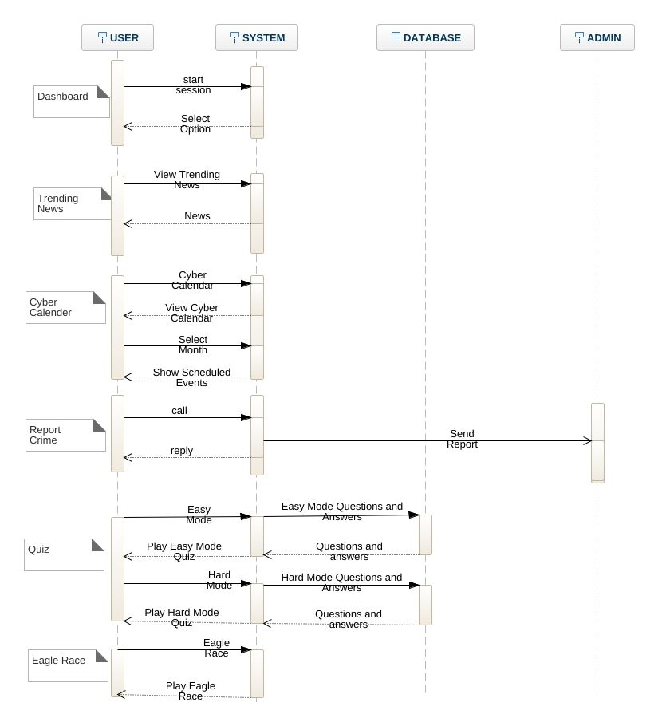

###### *Fig 4.7 - Sequence Diagram*

4.4.3. Package Diagrams

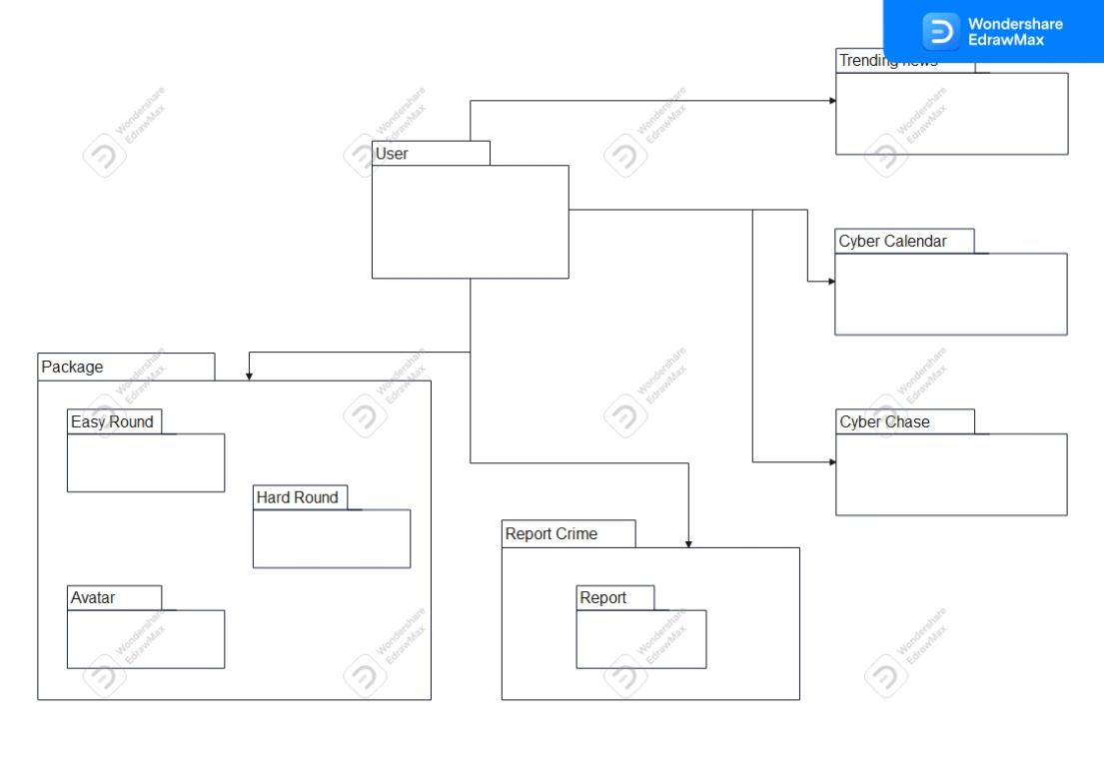

###### *Fig 4.8 - Package Diagram*

4.4.4. Pseudo-code/ Sample Code

#### Cyber Chase

public partial class Cyber_Chase : Form

{ int gravity;

int gravityValue = 8;

int obstacleSpeed = 10;

int score = 0;

int highScore = 0;

bool gameOver = false;

Random random = new Random();

public Cyber_Chase()

{InitializeComponent(); RestartGame();}

public static int parentX, parentY;

private void GameTimerEvent(object sender, EventArgs e)

{lblScore.Text = "Score: " + score;

lblhighScore.Text = "High Score: " + highScore;

player.Top += gravity;

if (player.Top > 607)

{gravity = 0; player.Top = 607; player.Image = Properties.Resources.run_down0;}

else if (player.Top < 60)

{gravity = 0; player.Top = 60; player.Image = Properties.Resources.run_up0;}

foreach (Control x in this.Controls)

{ if (x is PictureBox && (string)x.Tag == "obstacle")

{x.Left -= obstacleSpeed;

if (x.Left < -100)

{x.Left = random.Next(1200, 3000); score += 1;}

if (x.Bounds.IntersectsWith(player.Bounds))

{ gameTimer.Stop(); lblScore.Text += " Press Enter to Restart."; gameOver = true;

if (score > highScore)

{ highScore = score; }

} } }

if (score > 5){Level.Text = "LEVEL : TWO "; obstacleSpeed = 12; gravityValue = 12;}

else if (score > 10 && score <=15)

{ Level.Text = "LEVEL : THREE "; obstacleSpeed = 15;

gravityValue = 12;}

else if (score > 15 && score <= 20)

{ Level.Text = "LEVEL : FOUR "; obstacleSpeed = 18;

gravityValue = 12;}

else if (score > 20 && score <= 25)

{Level.Text = "LEVEL : FIVE "; obstacleSpeed = 25;

gravityValue = 12;}

else if (score > 25)

{ Level.Text = "LEVEL : FOUR "; obstacleSpeed = 30;

gravityValue = 12; } }

private void KeyIsUp(object sender, KeyEventArgs e)

{if (e.KeyCode == Keys.Up)

{ if (player.Top == 607)

{ player.Top -= 10; gravity = -gravityValue; }

else if( player.Top == 60) { player.Top += 10;

gravity = gravityValue; } }

if (e.KeyCode == Keys.Enter && gameOver == true)

{ RestartGame(); } }

private void RestartGame()

{ lblScore.Parent = pictureBox1;

lblhighScore.Parent = pictureBox2;

lblhighScore.Top = 0;

player.Location = new Point(24, 192);

player.Image = Properties.Resources.run_down0;

score = 0;

gravityValue = 8;

gravity = gravityValue;

obstacleSpeed = 10;

Level.Text = "LEVEL : ONE ";

foreach (Control x in this.Controls)

{if (x is PictureBox && (string)x.Tag == "obstacle")

{ x.Left = random.Next(1200, 3000); }

if (x is PictureBox && (string)x.Tag == "bonus")

{ x.Left = random.Next(1200, 3000); } }

gameTimer.Start();

}

private void toolStripMenuItem8_Click(object sender, EventArgs e)

{this.Hide();

MainMenu mainMenu = new MainMenu();

mainMenu.ShowDialog(); }

private void toolStripMenuItem5_Click(object sender, EventArgs e)

{this.Hide(); Trending_News tnews = new Trending_News();

tnews.ShowDialog(); }

private void toolStripMenuItem6_Click(object sender, EventArgs e)

{ this.Hide(); Cyber_Calender cyber_Calender = new Cyber_Calender(); cyber_Calender.ShowDialog(); }

private void toolStripMenuItem7_Click(object sender, EventArgs e)

{ this.Hide(); Report_Crime report_Crime = new Report_Crime();

report_Crime.ShowDialog(); }

private void toolStripMenuItem3_Click(object sender, EventArgs e)

{ this.Hide(); CyberQuiz cyquiz = new CyberQuiz();

cyquiz.ShowDialog(); } }.

#### Easy Round - Quiz Game

namespace Cyber_Security_Alerts_Gaming_System_01

{

public partial class Report_Crime : Form

{

OpenFileDialog open = new OpenFileDialog();

public Report_Crime()

{

InitializeComponent();

}

private void birdGameToolStripMenuItem_Click(object sender, EventArgs e)

{

this.Hide();

Cyber_Chase bird_Game = new Cyber_Chase();

bird_Game.ShowDialog();

}

private void quizGameToolStripMenuItem_Click(object sender, EventArgs e)

{

this.Hide();

CyberQuiz cyquiz = new CyberQuiz();

cyquiz.ShowDialog();

}

private void cyberCalenderToolStripMenuItem_Click(object sender, EventArgs e)

{

this.Hide();

Cyber_Calender cyber_Calender = new Cyber_Calender();

cyber_Calender.ShowDialog();

}

private void trendingNewsToolStripMenuItem_Click(object sender, EventArgs e)

{

this.Hide();

Trending_News trending_News = new Trending_News();

trending_News.ShowDialog();

}

private void homeToolStripMenuItem_Click(object sender, EventArgs e)

{

this.Hide();

MainMenu mainMenu = new MainMenu();

mainMenu.ShowDialog();

}

private void submitb_Click(object sender, EventArgs e)

{

TextWriter textWriter = new StreamWriter("C:\\Users\\Sandy\\Downloads\\Report.txt");

textWriter.Write("Complainant's Name \n" + u.Text + "\n Contact Number \n" + number.Text + "\n Approximate Date of incident \n" + date.Text + "\n Reason for Delay in reporting \n" + reason.Text + "\nAddress\n" + Address.Text + "\n Town/ City / District \n" + town.Text + "\n Nearest police Station \n" + police.Text + "\n Please explain where and how the incident happened and any additional information you may deem necessary to the incident. \n" + explain.Text + "\n" );

textWriter.Close();

if (Address.Text == "")

{

MessageBox.Show("Please fill in the Address","MISSING DATA",MessageBoxButtons.OK,MessageBoxIcon.Exclamation);

}

else if (police.Text == "")

{

MessageBox.Show("Please fill in the Nearest Police Station", "MISSING DATA", MessageBoxButtons.OK, MessageBoxIcon.Exclamation);

}

else if (town.Text == "")

{

MessageBox.Show("Please fill in the Town/City", "MISSING DATA", MessageBoxButtons.OK, MessageBoxIcon.Exclamation);

}

else if (explain.Text == "")

{

MessageBox.Show("Please fill in the Explaination", "MISSING DATA", MessageBoxButtons.OK, MessageBoxIcon.Exclamation);

}

else

{

send.ForeColor = Color.Green;

send.Text = "Report Send";

}

open.Filter = "Text Files(*. text)|*.TXT";

if (this.WindowState == FormWindowState.Minimized)

{

this.Hide();

notifyIcon1.ShowBalloonTip(1000, "Important Message", "Report Send.", ToolTipIcon.Info);

}

}

private void uploadFile(string fileName)

{

try

{

var client = new WebClient();

{

client.Headers.Add("fileName", System.IO.Path.GetFileName(fileName));

MessageBox.Show("Your Report was Successfully sent");

}

}

catch (Exception ex)

{

MessageBox.Show(ex.Message);

}

}

private void Submit(object sender, EventArgs e)

{

if (this.WindowState == FormWindowState.Minimized)

{

this.Hide();

notifyIcon1.ShowBalloonTip(1000, "Important Message", "Report Send.", ToolTipIcon.Info);

}

}

private void ShowNotif(object sender, EventArgs e)

{

this.Show();

}

private void Q1_Click(object sender, EventArgs e)

{

answer.Text = "Cybercrime is any criminal activity that involves a computer, networked device, or a network. It can include activities such as generating profit for the cybercriminal, damaging or disabling computers or devices, spreading malware, illegal information, images, or other materials";

}

private void Q2_Click(object sender, EventArgs e)

{

answer.Text = "There are many types of cybercrime, including \n \t phishing, \n \t hacking, \n \t identity theft, \n \t cyberbullying, \n \t cyberstalking";

}

private void Q3_Click(object sender, EventArgs e)

{

answer.Text = "In Zimbabwe, you can report cybercrime complaints such as mobile crimes, online and social media crimes to the police.";

}

private void Q4_Click(object sender, EventArgs e)

{

answer.Text = "To protect yourself from cyber attacks, \n \t you can use strong passwords,\n \t keep your software up to date, \n \t use antivirus software, \n \tbe cautious of suspicious emails or links, \n \t avoid sharing personal information online";

}

private void Q5_Click(object sender, EventArgs e)

{

answer.Text = "The Zimbabwean police are responsible for investigating and detecting all serious crimes in Zimbabwe, including cybercrime";

}

}

}

### **4.5. Interface Design**

### 4.5.1. Dashboard

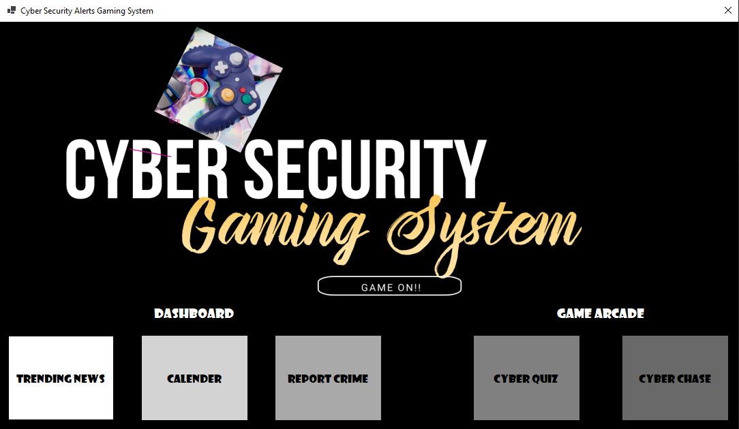

###### *Fig 4.9 - Dashboard*

### 4.5.2. Trending News

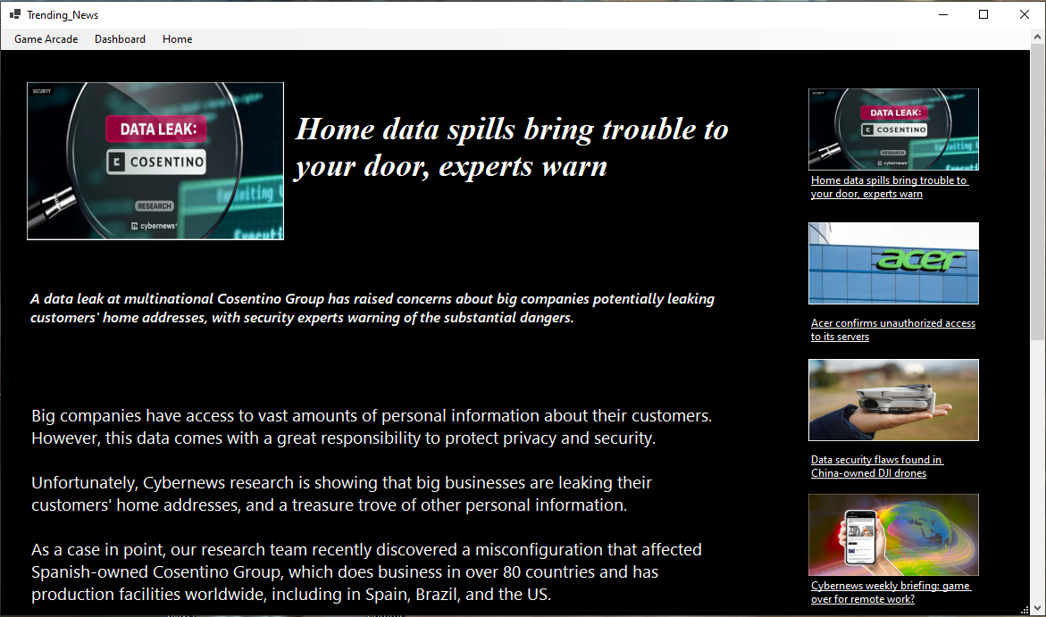

###### *Fig 4.10 - Trending News*

4.5.3. Calendar

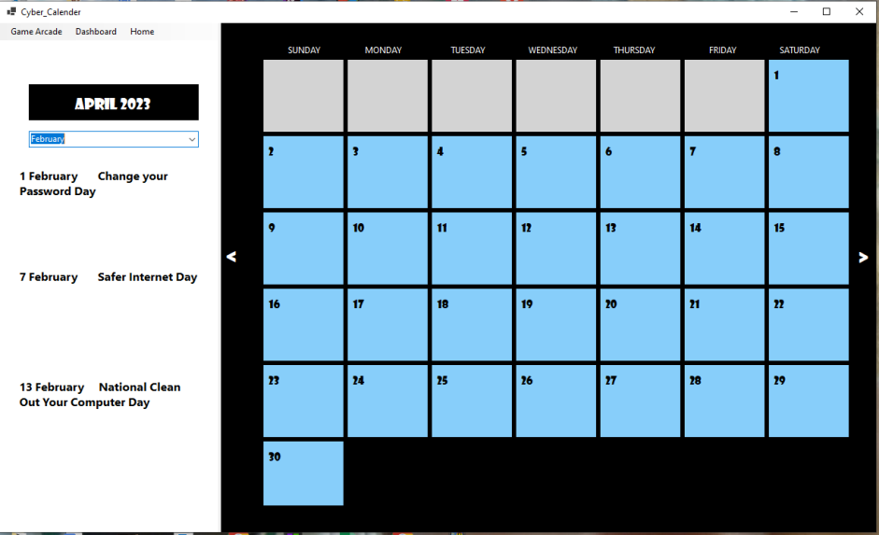

###### *Fig 4.11- Cyber Calendar*

### 4.5.4. Report Crime

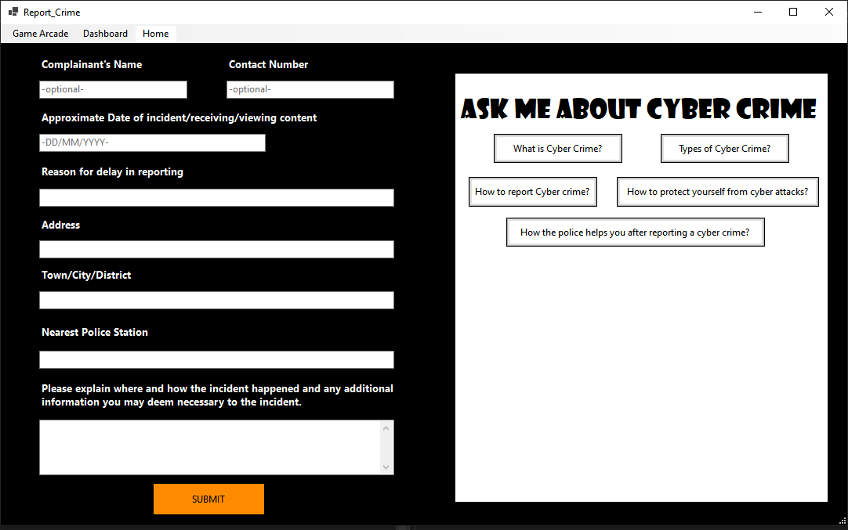

###### *Fig 4.13 - Report Crime*

### 4.5.5. Quiz

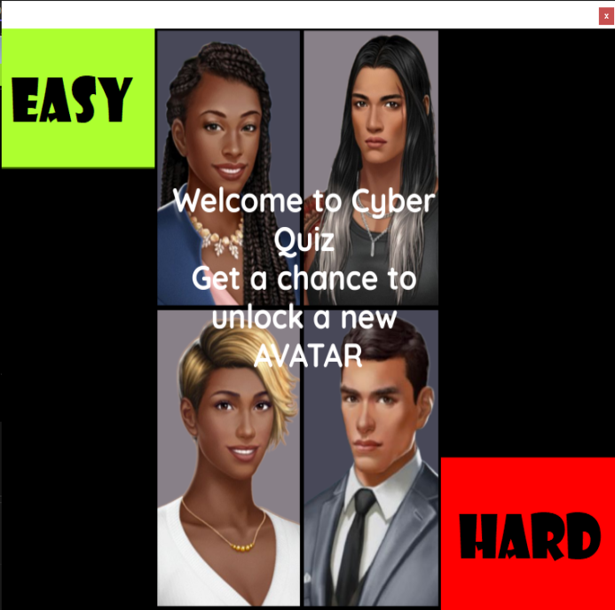

###### *Fig 4.14 - Quiz Menu*

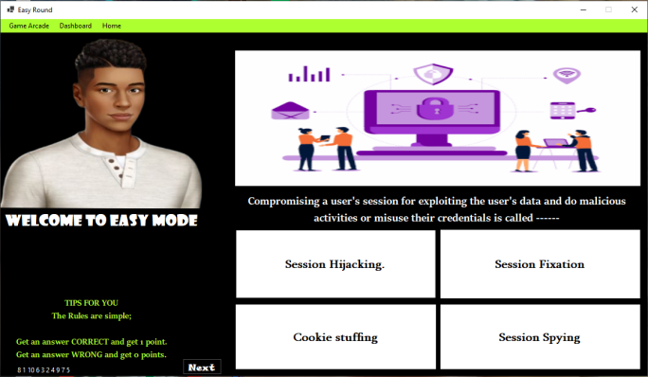

###### *Fig 4.15 - Easy Quiz*

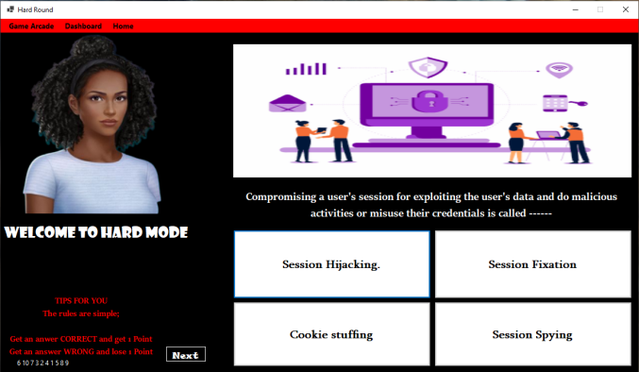

###### *Fig 4.16 - Hard Quiz*

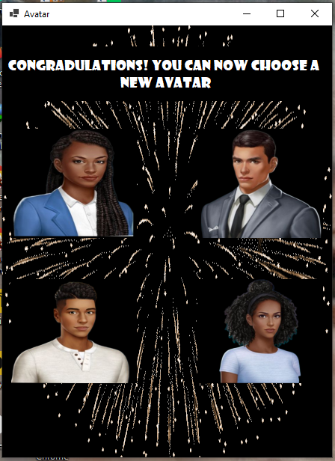

*Fig 4.17 - Avatar*

### 4.5.6. Cyber Chase

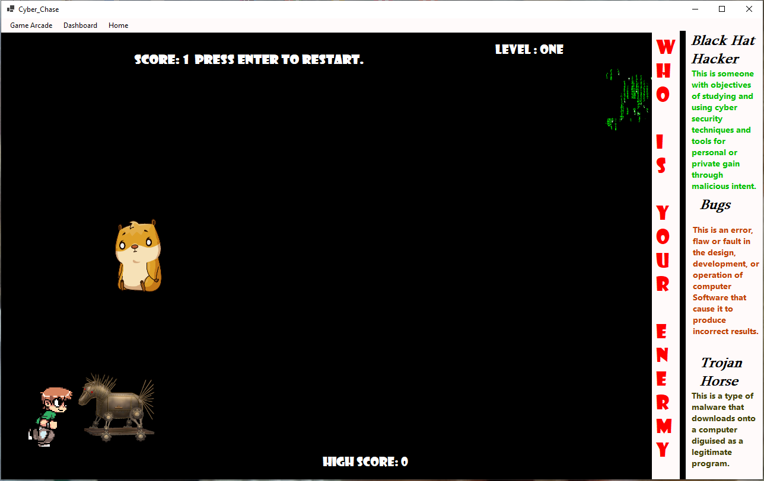

###### *Fig 4.18 - Cyber Chase*

CHAPTER 5: IMPLEMENTATION AND TESTING

## 5.1. Sample Code

### 5.1.1. Dashboard

public partial class MainMenu : Form

{

public MainMenu()

{

InitializeComponent();

}

private void quizb_Click(object sender, EventArgs e)

{

this.Hide();

CyberQuiz cyquiz = new CyberQuiz();

cyquiz.ShowDialog();

}

private void birdgameb_Click(object sender, EventArgs e)

{

this.Hide();

Bird_Game bird_Game = new Bird_Game();

bird_Game.ShowDialog();

}

private void reportb_Click(object sender, EventArgs e)

{

this.Hide();

Report_Crime report_Crime = new Report_Crime();

report_Crime.ShowDialog();

}

private void calenderb_Click(object sender, EventArgs e)

{

this.Hide();

Cyber_Calender cyber_Calender = new Cyber_Calender();

cyber_Calender.ShowDialog();

}

private void trendingb_Click(object sender, EventArgs e)

{

this.Hide();

Trending_News trending_News = new Trending_News();

trending_News.ShowDialog();

}

}

### 5.1.2. Trending News

public partial class Trending_News : Form

{

public Trending_News()

{

InitializeComponent();

}

private void birdGameToolStripMenuItem_Click(object sender, EventArgs e)

{

this.Hide();

Bird_Game bird_Game = new Bird_Game();

bird_Game.ShowDialog();

}

private void quizGameToolStripMenuItem_Click(object sender, EventArgs e)

{

this.Hide();

CyberQuiz cyquiz = new CyberQuiz();

cyquiz.ShowDialog();

}

private void reportCrimeToolStripMenuItem_Click(object sender, EventArgs e)

{

this.Hide();

Report_Crime report_Crime = new Report_Crime();

report_Crime.ShowDialog();

}

private void cyberCalenderToolStripMenuItem_Click(object sender, EventArgs e)

{

this.Hide();

Cyber_Calender cyber_Calender = new Cyber_Calender();

cyber_Calender.ShowDialog();

}

private void homeToolStripMenuItem_Click(object sender, EventArgs e)

{

this.Hide();

MainMenu mainMenu = new MainMenu();

mainMenu.ShowDialog();

}

private void linkLabel4_LinkClicked(object sender, LinkLabelLinkClickedEventArgs e)

{

newbox.Image = Properties.Resources._3___Copy;

HeadlineL.Text = "Label 4";

news.Text = "Whats is the name of the main character from Iron Man?";

}

private void Label1_LinkClicked(object sender, LinkLabelLinkClickedEventArgs e)

{

newbox.Image = Properties.Resources._4___Copy;

_ = HeadlineL.Text = "Label 1";

news.Text = "Which Game Publisher Made the game above?";

}

private void Label2_LinkClicked(object sender, LinkLabelLinkClickedEventArgs e)

{

newbox.Image = Properties.Resources._3___Copy;

_ = HeadlineL.Text = "Label 2";

news.Text = "Whats is the name of the main character from Iron Man?";

}

private void Label3_LinkClicked(object sender, LinkLabelLinkClickedEventArgs e)

{

newbox.Image = Properties.Resources._5___Copy;

_ = HeadlineL.Text = "Label 3";

news.Text = "Who is Geralt looking for in this game?";

}

private void Trending_News_Load(object sender, EventArgs e)

{

}

}

}5.1.3. Cyber-Calendar

public partial class Cyber_Calender : Form

{

int month, year;

public Cyber_Calender()

{

InitializeComponent();

}

private void Cyber_Calender_Load(object sender, EventArgs e)

{

displaDays();

comboBox1.Text = DateTimeFormatInfo.CurrentInfo.GetMonthName(month);

}

private void displaDays()

{

DateTime now = DateTime.Now;

month = now.Month;

year = now.Year;

string monthname = DateTimeFormatInfo.CurrentInfo.GetMonthName(month);

LBDATE.Text = monthname + " " + year;

comboBox1.Text = monthname;

DateTime startofthemonth = new DateTime(year, month, 1);

int days = DateTime.DaysInMonth(year, month);

int dayoftheweek = Convert.ToInt32(startofthemonth.DayOfWeek.ToString("d")) + 1;

for (int i = 1; i < dayoftheweek; i++)

{

Calender ucblank = new Calender();

daycontainer.Controls.Add(ucblank);

}

for (int i = 1; i <= days; i++)

{

UserControlDays ucdays = new UserControlDays();

ucdays.days(i);

daycontainer.Controls.Add(ucdays);

}

}

private void next_Click(object sender, EventArgs e)

{

daycontainer.Controls.Clear();

month++;

string monthname = DateTimeFormatInfo.CurrentInfo.GetMonthName(month);

LBDATE.Text = monthname + " " + year;

comboBox1.Text = monthname;

DateTime startofthemonth = new DateTime(year, month, 1);

int days = DateTime.DaysInMonth(year, month);

int dayoftheweek = Convert.ToInt32(startofthemonth.DayOfWeek.ToString("d")) + 1;

for (int i = 1; i < dayoftheweek; i++)

{

Calender ucblank = new Calender();

daycontainer.Controls.Add(ucblank);

}

for (int i = 1; i <= days; i++)

{

UserControlDays ucdays = new UserControlDays();

ucdays.days(i);

daycontainer.Controls.Add(ucdays);

}

}

private void previous_Click(object sender, EventArgs e)

{

daycontainer.Controls.Clear();

month--;

string monthname = DateTimeFormatInfo.CurrentInfo.GetMonthName(month);

LBDATE.Text = monthname + " " + year;

comboBox1.Text = monthname;

DateTime startofthemonth = new DateTime(year, month, 1);

int days = DateTime.DaysInMonth(year, month);

int dayoftheweek = Convert.ToInt32(startofthemonth.DayOfWeek.ToString("d")) + 1;

for (int i = 1; i < dayoftheweek; i++)

{

Calender ucblank = new Calender();

daycontainer.Controls.Add(ucblank);

}

for (int i = 1; i <= days; i++)

{

UserControlDays ucdays = new UserControlDays();

ucdays.days(i);

daycontainer.Controls.Add(ucdays);

}

}

private void birdGameToolStripMenuItem_Click_1(object sender, EventArgs e)

{

this.Hide();

Bird_Game bird_Game = new Bird_Game();

bird_Game.ShowDialog();

}

private void quizGameToolStripMenuItem_Click_1(object sender, EventArgs e)

{

this.Hide();

CyberQuiz cyquiz = new CyberQuiz();

cyquiz.ShowDialog();

}

private void trendingNewsToolStripMenuItem_Click_1(object sender, EventArgs e)

{

this.Hide();

Trending_News trending_News = new Trending_News();

trending_News.ShowDialog();

}

private void reportCrimeToolStripMenuItem_Click_1(object sender, EventArgs e)

{

this.Hide();

Report_Crime report_Crime = new Report_Crime();

report_Crime.ShowDialog();

}

private void comboBox1_SelectedIndexChanged(object sender, EventArgs e)

{

if(comboBox1.Text == "January")

{

label7.Text = "22 - 28 January " + " DataPrivacy Week" ;

label8.Text = " ";

label9.Text = " ";

}

else if (comboBox1.Text == "February")

{

label7.Text = "1 February " + " Change your Password Day";

label8.Text = "7 February " + "Safer Internet Day";

label9.Text = "13 February " + "National Clean Out Your Computer Day";

}

else if (comboBox1.Text == "March")

{

label7.Text = "31 March " + " World BackUp Day";

label8.Text = " ";

label9.Text = " ";

}

else if (comboBox1.Text == "April")

{

label7.Text = "11 April " +" Identity Management Day";

label8.Text = " ";

label9.Text = " ";

}

else if (comboBox1.Text == "May")

{

label7.Text = "4 May " + " World Password Day";

label8.Text = " ";

label9.Text = " ";

}

else if (comboBox1.Text == "June")

{

label7.Text = "" + " ";

label8.Text = " Stay Safe While On The Cyber Space ";

label9.Text = " ";

}

else if (comboBox1.Text == "July")

{

label7.Text = "" + " ";

label8.Text = " Stay Safe While On The Cyber Space";

label9.Text = " ";

}

else if (comboBox1.Text == "August")

{

label7.Text = "" + " ";

label8.Text = " Stay Safe While On The Cyber Space";

label9.Text = " ";

}

else if (comboBox1.Text == "September")

{

label7.Text = "" + " ";

label8.Text = " Stay Safe While On The Cyber Space";

label9.Text = " ";

}

else if (comboBox1.Text == "October")

{

label7.Text = "1 - 31 October " + "National Cyber Security Month";

label8.Text = "29 Coctober " + "National Internet Day ";

label9.Text = " ";

}

else if (comboBox1.Text == "November")

{

label7.Text = "12 - 18 November " + " International Fraud Awareness Week";

label8.Text = "30 November" + "Computer Security Day";

label9.Text = " ";

}

else if (comboBox1.Text == "December")

{

label7.Text = " " + " ";

label8.Text = "Stay Safe While On The Cyber Space ";

label9.Text = " ";

}

}

private void homeToolStripMenuItem_Click_1(object sender, EventArgs e)

{

this.Hide();

MainMenu mainMenu = new MainMenu();

mainMenu.ShowDialog();

} }5.1.4. Report Crime

public partial class Report_Crime : Form

{

OpenFileDialog open = new OpenFileDialog();

public Report_Crime()

{

InitializeComponent();

}

private void birdGameToolStripMenuItem_Click(object sender, EventArgs e)

{

this.Hide();

Cyber_Chase bird_Game = new Cyber_Chase();

bird_Game.ShowDialog();

}

private void quizGameToolStripMenuItem_Click(object sender, EventArgs e)

{

this.Hide();

CyberQuiz cyquiz = new CyberQuiz();

cyquiz.ShowDialog();

}

private void cyberCalenderToolStripMenuItem_Click(object sender, EventArgs e)

{

this.Hide();

Cyber_Calender cyber_Calender = new Cyber_Calender();

cyber_Calender.ShowDialog();

}

private void trendingNewsToolStripMenuItem_Click(object sender, EventArgs e)

{

this.Hide();

Trending_News trending_News = new Trending_News();

trending_News.ShowDialog();

}

private void homeToolStripMenuItem_Click(object sender, EventArgs e)

{

this.Hide();

MainMenu mainMenu = new MainMenu();

mainMenu.ShowDialog();

}

private void submitb_Click(object sender, EventArgs e)

{

TextWriter textWriter = new StreamWriter("C:\\Users\\Sandy\\Downloads\\Report.txt");

textWriter.Write("Complainant's Name \n" + textBox1.Text + "\n Contact Number \n" + textBox2.Text + "\n Approximate Date of incident \n" + textBox3.Text + "\n Reason for Delay in reporting \n" + textBox4.Text + "\nAddress\n" + textBox5.Text + "\n Town/ City / District \n" + textBox6.Text + "\n Nearest police Station \n" + textBox7.Text + "\n Please explain where and how the incident happened and any additional information you may deem necessary to the incident. \n" + textBox8.Text + "\n" );

textWriter.Close();

MessageBox.Show("Go to download,\n Select a File Named 'Report', \n Click Open");

send.ForeColor = Color.Green;

send.Text = "Report Send";

open.Filter = "Text Files(*. text)|*.TXT";

if (open.ShowDialog() == DialogResult.OK)

{

textBox1.Text = Path.GetFileName(open.FileName);

uploadFile(open.FileName);

}

if (this.WindowState == FormWindowState.Minimized)

{

this.Hide();

notifyIcon1.ShowBalloonTip(1000, "Important Message", "Report Send.", ToolTipIcon.Info);

}

}

private void uploadFile(string fileName)

{

try

{

var client = new WebClient();

{

client.Headers.Add("fileName", System.IO.Path.GetFileName(fileName));

MessageBox.Show("Your Report was Successfully sent");

}

}

catch (Exception ex)

{

MessageBox.Show(ex.Message);

}

}

private void Submit(object sender, EventArgs e)

{

if (this.WindowState == FormWindowState.Minimized)

{

this.Hide();

notifyIcon1.ShowBalloonTip(1000, "Important Message", "Report Send.", ToolTipIcon.Info);

}

}

private void ShowNotif(object sender, EventArgs e)

{

this.Show();

}

private void Q1_Click(object sender, EventArgs e)

{

answer.Text = "what is Cyber crime";

}

private void Q2_Click(object sender, EventArgs e)

{

answer.Text = "types of Cyber crime";

}

private void Q3_Click(object sender, EventArgs e)

{

answer.Text = "how to report Cyber crime";

}

private void Q4_Click(object sender, EventArgs e)

{

answer.Text = "protect yourself from cyber crime";

}

private void Q5_Click(object sender, EventArgs e)

{

answer.Text = "how police help";

}

private void checkmalware_Click(object sender, EventArgs e)

{

### 5.1.5. Quiz

public partial class CyberQuiz : Form {

public CyberQuiz() {

InitializeComponent();

}

private void easyb_Click(object sender, EventArgs e) {

this.Hide();

Quiz quiz = new Quiz();

quiz.ShowDialog();

}

private void hardb_Click(object sender, EventArgs e) {

this.Hide();

HardQuiz hquiz = new HardQuiz();

hquiz.ShowDialog();

} }

5.1.6. Cyber Chace

public partial class Bird_Game : Form

{

int gravity;

int gravityValue = 8;

int obstacleSpeed = 10;

int bonusSpeed = 10;

int score = 0;

int highScore = 0;

bool gameOver = false;

Random random = new Random();

public Bird_Game() {

InitializeComponent();

RestartGame();

}

private void GameTimerEvent(object sender, EventArgs e) {

lblScore.Text = "Score: " + score;

lblhighScore.Text = "High Score: " + highScore;

player.Top += gravity;

if (player.Top > 384) {

gravity = 0;

player.Top = 384;

}

else if (player.Top < 67) {

gravity = 0;

player.Top = 67;

}

foreach (Control x in this.Controls) {

if (x is PictureBox && (string)x.Tag == "obstacle") {

x.Left -= obstacleSpeed;

if (x.Left < -50)

{

x.Left = random.Next(1200, 3000);

score += 1;

}

if (x.Bounds.IntersectsWith(player.Bounds)) {

gameTimer.Stop();

Game_Over game_Over = new Game_Over();

DialogResult result = game_Over.ShowDialog();

if (result == DialogResult.OK) {

lblScore.Text += " Game Over!! Press Enter to Restart.";

gameOver = true;

if (score > highScore) {

highScore = score;

} } } }

if (x is PictureBox && (string)x.Tag == "bonus") {

x.Left -= bonusSpeed;

if (x.Left < -50) {

x.Left = random.Next(1200, 3000);

score += 1;

}

if (x.Bounds.IntersectsWith(player.Bounds)) {

score += 10;

} } }

if (score > 10) {

obstacleSpeed = 20;

gravityValue = 12;

} }

private void KeyIsUp(object sender, KeyEventArgs e) {

if (e.KeyCode == Keys.Up) {

if (player.Top == 384) {

player.Top -= 10;

gravity = -gravityValue;

}

else if (player.Top == 67) {

player.Top += 10;

gravity = gravityValue;

} }

if (e.KeyCode == Keys.Enter && gameOver == true) {

Game_Over game_Over = new Game_Over();

game_Over.ShowDialog();

RestartGame();

} }

private void RestartGame() {

lblScore.Parent = pictureBox1;

lblhighScore.Parent = pictureBox2;

lblhighScore.Top = 0;

player.Location = new Point(24, 192);

score = 0;

gravityValue = 8;

gravity = gravityValue;

obstacleSpeed = 10;

bonusSpeed = 10;

foreach (Control x in this.Controls) {

if (x is PictureBox && (string)x.Tag == "obstacle") {

x.Left = random.Next(1200, 3000);

}

if (x is PictureBox && (string)x.Tag == "bonus") {

x.Left = random.Next(1200, 3000);

} }

gameTimer.Start();

}

private void quizGameToolStripMenuItem_Click(object sender, EventArgs e) {

this.Hide();

CyberQuiz cyquiz = new CyberQuiz();

cyquiz.ShowDialog();

}

private void reportCrimeToolStripMenuItem_Click(object sender, EventArgs e) {

this.Hide();

Report_Crime report_Crime = new Report_Crime();

report_Crime.ShowDialog();

}

private void cyberCalenderToolStripMenuItem_Click(object sender, EventArgs e) {

this.Hide();

Cyber_Calender cyber_Calender = new Cyber_Calender();

cyber_Calender.ShowDialog();

}

private void trendingNewsToolStripMenuItem_Click(object sender, EventArgs e) {

this.Hide();

Trending_News trending_News = new Trending_News();

trending_News.ShowDialog();

}

private void homeToolStripMenuItem_Click(object sender, EventArgs e)

{

this.Hide();

MainMenu mainMenu = new MainMenu();

mainMenu.ShowDialog();

}

private void quitToolStripMenuItem_Click(object sender, EventArgs e)

{

RestartGame();

}

}

5.2. Software Testing

### 5.2.1. Unit Testing

Unit testing is a type of software testing that is done during the development phase of an application by the developers. It involves designing test cases to validate that the internal program logic is functioning properly and that program inputs produce valid outputs. In the context of the cyber security gaming system project, unit testing would involve testing individual software units of the application to ensure that each unique path of a business process performs accurately to the documented specifications and contains clearly defined inputs and expected results. This is a structural testing that isolates a section of code and verifies its correctness, including all decision branches and internal code flow. It is the first level of testing done before integration testing

### 5.2.3. Intergration

Integration testing is a type of software testing that is designed to test integrated software components to determine if they actually run as one program. In the context of the cyber security gaming system project, integration testing would involve testing various modules of the software under development as a group to see whether they function together seamlessly. Integration testing is event-driven and is more concerned with the basic outcome of screens or fields. It demonstrates that although the components were individually satisfactory, as shown by successfully unit testing, the combination of components is correct and consistent. Integration testing is specifically aimed at exposing the problems that arise from the combination of components and verifying that all the parts communicate well and work together to achieve the purpose of the software.

### 5.2.4. System Testing

System testing is a type of software testing that ensures that the entire integrated software system of the cyber security gaming system project meets requirements. It tests a configuration to ensure known and predictable results. An example of system testing is the configuration-oriented system integration test. System testing is based on process descriptions and flows, emphasizing pre-driven process links and integration points. It is a level of testing that validates the complete and fully integrated software product, evaluating the end-to-end system specifications. System testing is a black-box testing category of software testing that involves the external workings of the software from the user's perspective

### 5.2.6. Test Cases

##### *Unit Testing - Table 5.1*

|  |  |  |  |  |
| --- | --- | --- | --- | --- |
| **Test Case ID** | | **Action** | **Expected Results** | **Comment** |
|  | Start the system | | Display of the dashboard | Successful |
|  | Link to Trending news | | Load news onto window | Successfully uploaded news |
|  | Choose news headline link | | Load new NEWS headlines and news | Successfully uploaded news |
|  | Link to Cyber Calender | | Load events and calender onto screen | Successfully load calender |
|  | View month | | Load the current selected month onto calender and display the events in events panel | Viewed Successfully |
|  | Link to Report Crime | | Load Form | Viewed successfully |
|  | 'Submit’ report button | | Send Document to server | Send successfully |
|  | Fill in Number,  Date | | Validation of date and number | Formart for Number [236] --- ----  Date __/__/___ |
|  | Missing Data/ input | | Error Missing data from textbox on submit | Error Message |
|  | Link to Quiz | | Load Quiz Window  Link to Easy Quiz or  Link to Hard Quiz | Open Easy Quiz  or  Open Hard Quiz |
|  | Easy and Hard Quiz Game - Choose correct answer to question | | Accept answer  Score + 1 | Score increase by 1 |
|  | Easy Quiz Game - Choose wrong answer to question | | Decline answer | Score remains unchanged |
|  | Hard Quiz Game - Choose wrong answer to question | | Decline answer  Score - 1 | Score decrease by 1 |
|  | Link to Cyber Chase | | Load game |  |
|  | Control Character | | - Click ‘Up arrow’ to control Character.  -Increase speed at [5 * score] intervals. | Avoid ‘obstacles’ score + 1 / Obstacle avoided. |
|  | Game Over | | The Character meets with the ‘Obstacle’ | Game stops Successfully |
|  | Restart Game | | Click Enter to restart | Restart Successful |

##### *System Testing - Table 5.2*

|  |  |  |  |
| --- | --- | --- | --- |
| **Test Case ID** | **Action** | **Expected Results** | **Comments** |
|  | Click on Desktop application Icon | The application launch/ open successfully | Application successfully opened |
|  | Fill in Number,  Date | Validation of date and number | Formart for Number [236] --- ----  Date __/__/___ |
|  | Missing Data/ input | Error Missing data from textbox on submit | Error Message |
|  | Submit | Input adata into Document successful  Successfully sent | Successfully sent |

## 5.3. •Installation & deployment, Maintenance

Hosting Server Requirements for the server :

• Microsoft visual studio c #

• MySQL (database)

• Xampp

How to start system

• Double tap on application icon shown below



*Fig 5.1 - System Icon*

CHAPTER 6: CONCLUSIONS AND RECOMMENDATIONS

## 6.1. Results and Summary

The system managed to meet its main objectives. As mentioned in the previous chapters, the system has two major parts; the Dashboard and the Game Arcade. The Dashboard is capable of giving the most recent news on cyber security and forward their report to their report to the police. The system also provides the user with a detailed cyber security based calender with events expected in each month. This meets the two objectives of spreading awareness to the public and creating a feature for people to report cyber crime directly to the police.

The Game Arcade fulfills the objective of using serious games to educate people on cyber security. The two games are meant to capture the interest of different ages of users, for instance, the quiz game that is more academically focused offers a chance to change avatars as a reward thus more appealing to the older users while the Cyber Chase of controlling a character to avoid obstacles would be more appealing to the younger users.

## 6.2. Recommendations and Future Works

### 6.2.1. Recommendations

Since the user will be using the system for the very first time, the developer recommends that users be given detailed instructions page with list of instructions / user manual and a short demo video of how to navigate through this system. Since this system is for all ages, for the younger users and older generation users, It can be necessary to offer to a candidate the information before they initiate as well as the benefits of the system to the users. I recommend the use of user-friendly, clear interfaces as well as interactive interfaces. I also recommend the use of visually appealing interfaces as well as keeping the system up to date with modern technologies.

### 6.2.2. Challenges

Acquiring a research material and data for cyber security was a bit of a challenge because some site were inaccessible in Zimbabwe.Development of the two games at once was a bit straining because of their reliance on the graphics resources of the computer, at one point the machine could not run the system until there was made a few changes in visuals of both games.

### 6.2.3. Future works

From the analysis of the proposed system and the prototype developed, I urge future researchers in the field of cyber security gaming system development to look at the following aspects so as to add to the work that has already been done:

1. Incorporating ways to detect cyber security break-in’s into the system

2. Add a feature for weapons in the cyber chase where user can shoot down the obstacle in its way

4. Use of chat board as a way for interactive interface for users to share experiences about cyber crime

BIBLIOGRAPHY: APPENDICES

## 7.1. APPENDIX A - Bibliography

## 7.1.1. References

[1] Winston Hill, Mescifint Fanuel, Xiaohong Yuan, (2020), Comparing Serious Games For Cyber Security Education, Retrieved from www.sites.asee.org

[2] Edutopia Article (26 March 2021), How to Enhance Classroom Learning. Retried from www.edutopia.org

[3] Fortnet Article (2022),. Cyber Security Statistics – 2022 Cyber Security Challenges.Retrieved from www.fortnet.com

[4]Purplesec (2020), Cyber Security Statistics The ultimate List of Stats Data and Trends for 2022. Retrieved from www.purplesec.us

7.2. APPENDIX B - User Manual Of Working System

### **Introduction**

Welcome to Cyber Security Gaming System. This Manual will guide you on using Cyber Security Gaming System from the point of setting up. It i s recommended you use a computer with the following minimum requirements.

* 32/64 - bit computer
* 2 Gig RAM
* At least 8 GB of free HDD Space
* USB 2 interface
* .NET 3.5 Framework
* Xampp

If you have a computer with these minimum requirements, you are ready to go.

### **Prototype Overview**

### 7.2.1. Dashboard

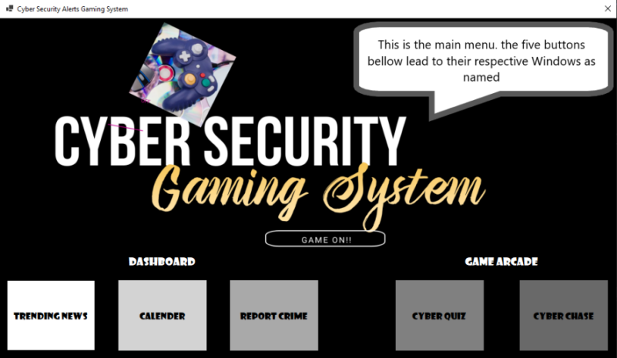

###### *Fig 7.1 - Dashboard*

### 7.2.2. Trending News

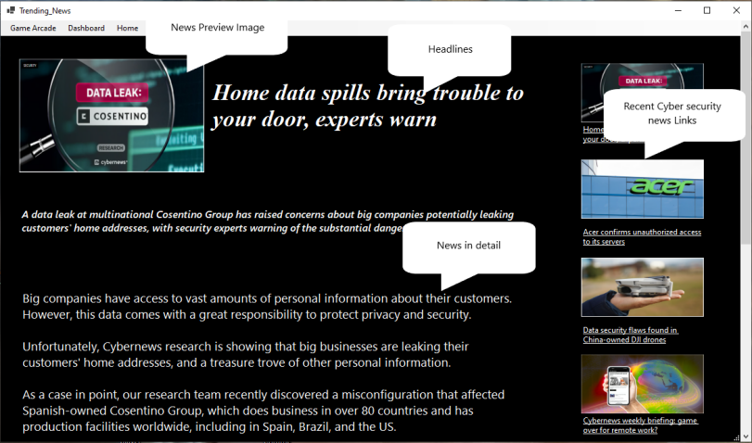

###### *Fig 7.2 - Trendind News*

### 7.2.3. Calendar

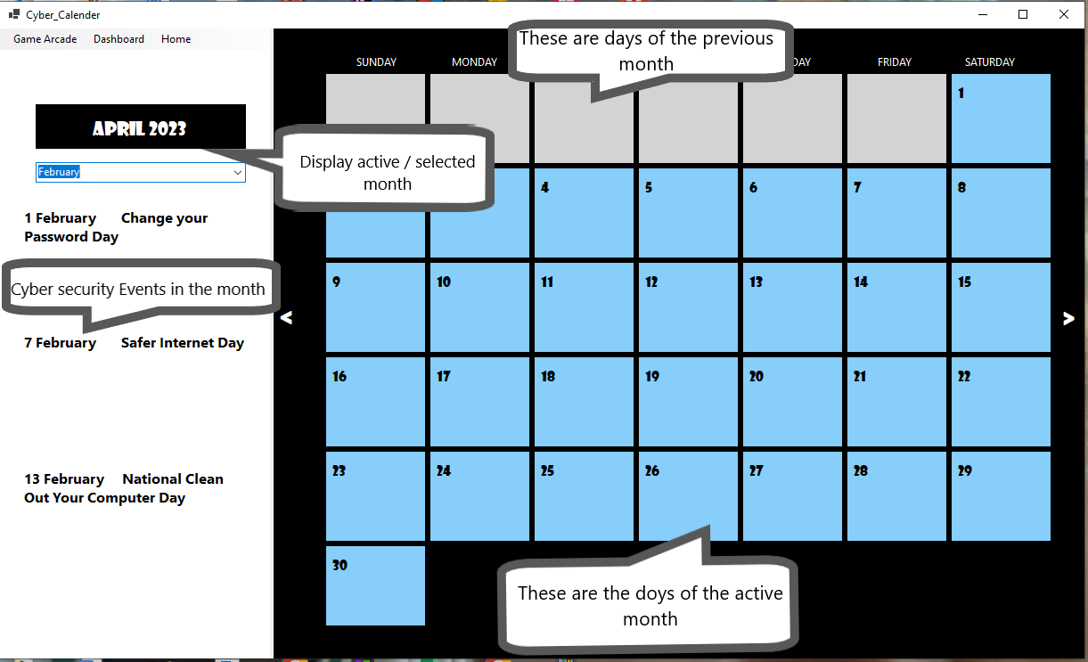

###### *Fig 7.3 - Cyber Calendar*

### 7.2.4. Report Crime

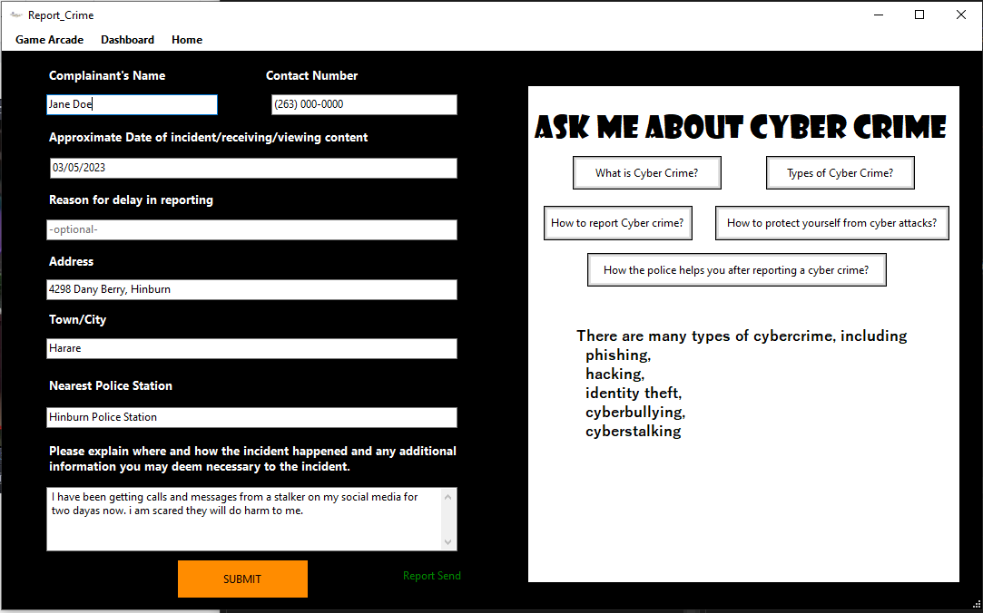

###### *Fig 7.4 - Report Crime*

### 7.2.5. Quiz

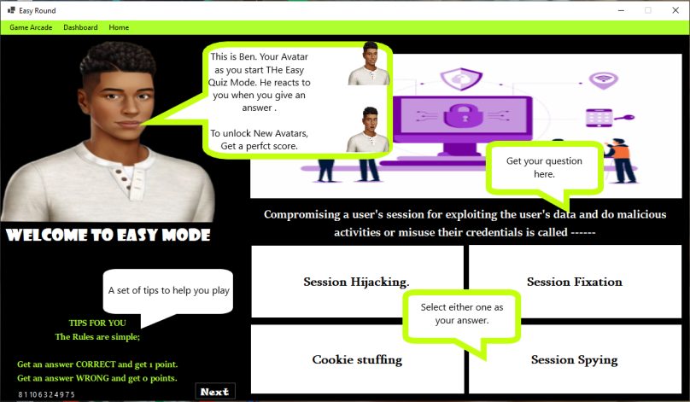

###### *Fig 7.5 - Easy Quiz*

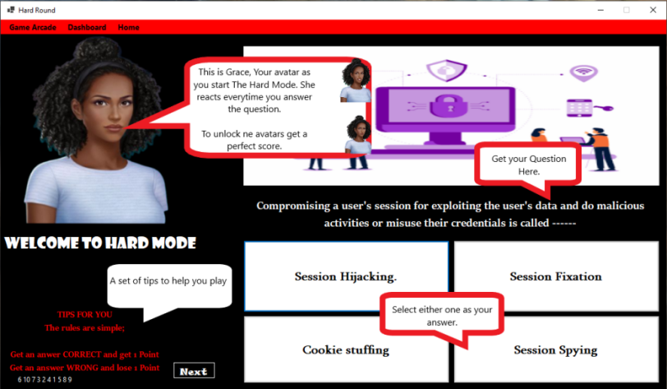

###### *Fig 7.6 - Hard Quiz*

### 7.2.6. Cyber Chase

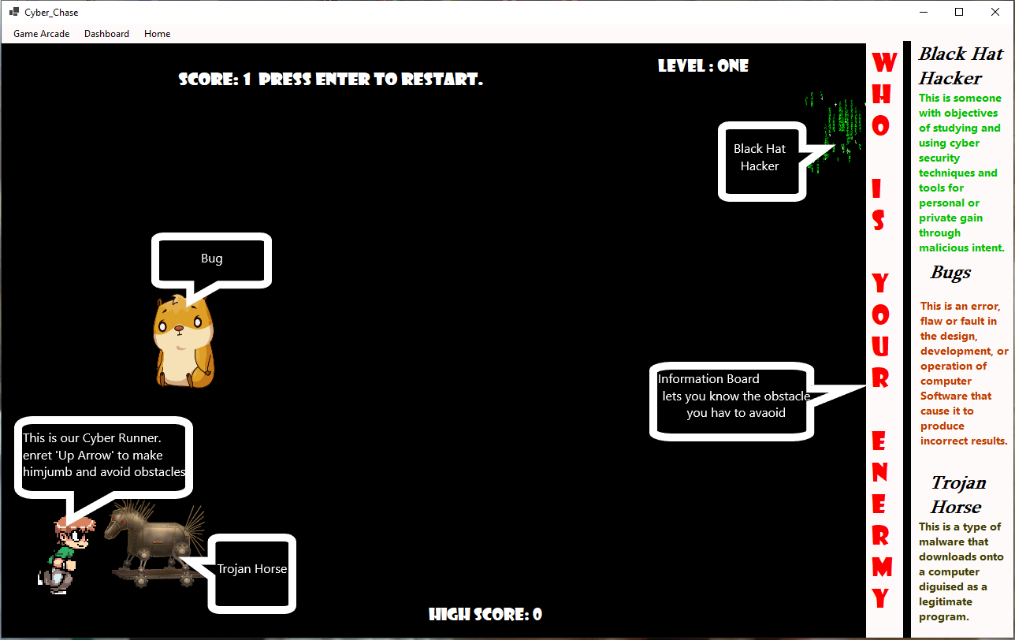

###### *Fig 7.7 - Cyber Chase*

## **Exiting the system**

To Exit the system, right click on the exit button icon at the top right corner of the window.

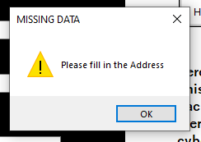

## 7.3. APPENDIX C - Sample Code

### 7.3.1. Dashboard

public partial class MainMenu : Form

{

public MainMenu()

{

InitializeComponent();

}

private void quizb_Click(object sender, EventArgs e)

{

this.Hide();

CyberQuiz cyquiz = new CyberQuiz();

cyquiz.ShowDialog();

}

private void birdgameb_Click(object sender, EventArgs e)

{

this.Hide();

Bird_Game bird_Game = new Bird_Game();

bird_Game.ShowDialog();

}

private void reportb_Click(object sender, EventArgs e)

{

this.Hide();

Report_Crime report_Crime = new Report_Crime();

report_Crime.ShowDialog();

}

private void calenderb_Click(object sender, EventArgs e)

{

this.Hide();

Cyber_Calender cyber_Calender = new Cyber_Calender();

cyber_Calender.ShowDialog();

}

private void trendingb_Click(object sender, EventArgs e)

{

this.Hide();

Trending_News trending_News = new Trending_News();

trending_News.ShowDialog();

}

}

### 7.1.2. Trending News

public partial class Trending_News : Form

{

public Trending_News()

{

InitializeComponent();

}

private void birdGameToolStripMenuItem_Click(object sender, EventArgs e)

{

this.Hide();

Bird_Game bird_Game = new Bird_Game();

bird_Game.ShowDialog();

}

private void quizGameToolStripMenuItem_Click(object sender, EventArgs e)

{

this.Hide();

CyberQuiz cyquiz = new CyberQuiz();

cyquiz.ShowDialog();

}

private void reportCrimeToolStripMenuItem_Click(object sender, EventArgs e)

{

this.Hide();

Report_Crime report_Crime = new Report_Crime();

report_Crime.ShowDialog();

}

private void cyberCalenderToolStripMenuItem_Click(object sender, EventArgs e)

{

this.Hide();

Cyber_Calender cyber_Calender = new Cyber_Calender();

cyber_Calender.ShowDialog();

}

private void homeToolStripMenuItem_Click(object sender, EventArgs e)

{

this.Hide();

MainMenu mainMenu = new MainMenu();

mainMenu.ShowDialog();

}

private void linkLabel4_LinkClicked(object sender, LinkLabelLinkClickedEventArgs e)

{

newbox.Image = Properties.Resources._3___Copy;

HeadlineL.Text = "Label 4";

news.Text = "Whats is the name of the main character from Iron Man?";

}

private void Label1_LinkClicked(object sender, LinkLabelLinkClickedEventArgs e)

{

newbox.Image = Properties.Resources._4___Copy;

_ = HeadlineL.Text = "Label 1";

news.Text = "Which Game Publisher Made the game above?";

}

private void Label2_LinkClicked(object sender, LinkLabelLinkClickedEventArgs e)

{

newbox.Image = Properties.Resources._3___Copy;

_ = HeadlineL.Text = "Label 2";

news.Text = "Whats is the name of the main character from Iron Man?";

}

private void Label3_LinkClicked(object sender, LinkLabelLinkClickedEventArgs e)

{

newbox.Image = Properties.Resources._5___Copy;

_ = HeadlineL.Text = "Label 3";

news.Text = "Who is Geralt looking for in this game?";

}

}

}7.1.3. Cyber-Calendar

public partial class Cyber_Calender : Form

{

int month, year;

public Cyber_Calender()

{

InitializeComponent();

}

private void Cyber_Calender_Load(object sender, EventArgs e)

{

displaDays();

comboBox1.Text = DateTimeFormatInfo.CurrentInfo.GetMonthName(month);

}

private void displaDays()

{

DateTime now = DateTime.Now;

month = now.Month;

year = now.Year;

string monthname = DateTimeFormatInfo.CurrentInfo.GetMonthName(month);

LBDATE.Text = monthname + " " + year;

comboBox1.Text = monthname;

DateTime startofthemonth = new DateTime(year, month, 1);

int days = DateTime.DaysInMonth(year, month);

int dayoftheweek = Convert.ToInt32(startofthemonth.DayOfWeek.ToString("d")) + 1;

for (int i = 1; i < dayoftheweek; i++)

{

Calender ucblank = new Calender();

daycontainer.Controls.Add(ucblank);

}

for (int i = 1; i <= days; i++) {

UserControlDays ucdays = new UserControlDays();

ucdays.days(i);

daycontainer.Controls.Add(ucdays);

}}

private void next_Click(object sender, EventArgs e) {

daycontainer.Controls.Clear();

month++;

string monthname = DateTimeFormatInfo.CurrentInfo.GetMonthName(month);

LBDATE.Text = monthname + " " + year;

comboBox1.Text = monthname;

DateTime startofthemonth = new DateTime(year, month, 1);

int days = DateTime.DaysInMonth(year, month);

int dayoftheweek = Convert.ToInt32(startofthemonth.DayOfWeek.ToString("d")) + 1;

for (int i = 1; i < dayoftheweek; i++) {

Calender ucblank = new Calender();

daycontainer.Controls.Add(ucblank);

}

for (int i = 1; i <= days; i++){

UserControlDays ucdays = new UserControlDays();

ucdays.days(i);

daycontainer.Controls.Add(ucdays);

}

}

private void previous_Click(object sender, EventArgs e){

daycontainer.Controls.Clear();

month--;

string monthname = DateTimeFormatInfo.CurrentInfo.GetMonthName(month);

LBDATE.Text = monthname + " " + year;

comboBox1.Text = monthname;

DateTime startofthemonth = new DateTime(year, month, 1);

int days = DateTime.DaysInMonth(year, month);

int dayoftheweek = Convert.ToInt32(startofthemonth.DayOfWeek.ToString("d")) + 1;

for (int i = 1; i < dayoftheweek; i++){

Calender ucblank = new Calender();

daycontainer.Controls.Add(ucblank);

}

for (int i = 1; i <= days; i++){

UserControlDays ucdays = new UserControlDays();

ucdays.days(i);

daycontainer.Controls.Add(ucdays);

} }

private void birdGameToolStripMenuItem_Click_1(object sender, EventArgs e) {

this.Hide();

Bird_Game bird_Game = new Bird_Game();

bird_Game.ShowDialog();

}

private void quizGameToolStripMenuItem_Click_1(object sender, EventArgs e) {

this.Hide();

CyberQuiz cyquiz = new CyberQuiz();

cyquiz.ShowDialog();

}

private void trendingNewsToolStripMenuItem_Click_1(object sender, EventArgs e) {

this.Hide();

Trending_News trending_News = new Trending_News();

trending_News.ShowDialog();

}

private void reportCrimeToolStripMenuItem_Click_1(object sender, EventArgs e) {

this.Hide();

Report_Crime report_Crime = new Report_Crime();

report_Crime.ShowDialog();

}

private void comboBox1_SelectedIndexChanged(object sender, EventArgs e) {

if(comboBox1.Text == "January") {

label7.Text = "22 - 28 January " + " DataPrivacy Week" ;

label8.Text = " ";

label9.Text = " ";

}

else if (comboBox1.Text == "February") {

label7.Text = "1 February " + " Change your Password Day";

label8.Text = "7 February " + "Safer Internet Day";

label9.Text = "13 February " + "National Clean Out Your Computer Day";

}

else if (comboBox1.Text == "March") {

label7.Text = "31 March " + " World BackUp Day";

label8.Text = " ";

label9.Text = " ";

}

else if (comboBox1.Text == "April") {

label7.Text = "11 April " +" Identity Management Day";

label8.Text = " ";

label9.Text = " ";

}

else if (comboBox1.Text == "May") {

label7.Text = "4 May " + " World Password Day";

label8.Text = " ";

label9.Text = " ";

}

else if (comboBox1.Text == "June") {

label7.Text = "" + " ";

label8.Text = " Stay Safe While On The Cyber Space ";

label9.Text = " ";

}

else if (comboBox1.Text == "July") {

label7.Text = "" + " ";

label8.Text = " Stay Safe While On The Cyber Space";

label9.Text = " ";

}

else if (comboBox1.Text == "August") {

label7.Text = "" + " ";

label8.Text = " Stay Safe While On The Cyber Space";

label9.Text = " ";

}

else if (comboBox1.Text == "September") {

label7.Text = "" + " ";

label8.Text = " Stay Safe While On The Cyber Space";

label9.Text = " ";

}

else if (comboBox1.Text == "October") {

label7.Text = "1 - 31 October " + "National Cyber Security Month";

label8.Text = "29 Coctober " + "National Internet Day ";

label9.Text = " ";

}

else if (comboBox1.Text == "November") {

label7.Text = "12 - 18 November " + " International Fraud Awareness Week";

label8.Text = "30 November" + "Computer Security Day";

label9.Text = " ";

}

else if (comboBox1.Text == "December") {

label7.Text = " " + " ";

label8.Text = "Stay Safe While On The Cyber Space ";

label9.Text = " ";

} }

private void homeToolStripMenuItem_Click_1(object sender, EventArgs e) {

this.Hide();

MainMenu mainMenu = new MainMenu();

mainMenu.ShowDialog();

} }

7.1.4. Report Crime

public partial class Report_Crime : Form

{

OpenFileDialog open = new OpenFileDialog();

public Report_Crime(){

InitializeComponent();

}

private void birdGameToolStripMenuItem_Click(object sender, EventArgs e) {

this.Hide();

Cyber_Chase bird_Game = new Cyber_Chase();

bird_Game.ShowDialog();

}

private void quizGameToolStripMenuItem_Click(object sender, EventArgs e) {

this.Hide();

CyberQuiz cyquiz = new CyberQuiz();

cyquiz.ShowDialog();

}

private void cyberCalenderToolStripMenuItem_Click(object sender, EventArgs e)

{

this.Hide();

Cyber_Calender cyber_Calender = new Cyber_Calender();

cyber_Calender.ShowDialog();

}

private void trendingNewsToolStripMenuItem_Click(object sender, EventArgs e)

{

this.Hide();

Trending_News trending_News = new Trending_News();

trending_News.ShowDialog();

}

private void homeToolStripMenuItem_Click(object sender, EventArgs e)

{

this.Hide();

MainMenu mainMenu = new MainMenu();

mainMenu.ShowDialog();

}

private void submitb_Click(object sender, EventArgs e)

{

TextWriter textWriter = new StreamWriter("C:\\Users\\Sandy\\Downloads\\Report.txt");

textWriter.Write("Complainant's Name \n" + textBox1.Text + "\n Contact Number \n" + textBox2.Text + "\n Approximate Date of incident \n" + textBox3.Text + "\n Reason for Delay in reporting \n" + textBox4.Text + "\nAddress\n" + textBox5.Text + "\n Town/ City / District \n" + textBox6.Text + "\n Nearest police Station \n" + textBox7.Text + "\n Please explain where and how the incident happened and any additional information you may deem necessary to the incident. \n" + textBox8.Text + "\n" );

textWriter.Close();

MessageBox.Show("Go to download,\n Select a File Named 'Report', \n Click Open");

send.ForeColor = Color.Green;

send.Text = "Report Send";

open.Filter = "Text Files(*. text)|*.TXT";

if (open.ShowDialog() == DialogResult.OK)

{

textBox1.Text = Path.GetFileName(open.FileName);

uploadFile(open.FileName);

}

if (this.WindowState == FormWindowState.Minimized)

{

this.Hide();

notifyIcon1.ShowBalloonTip(1000, "Important Message", "Report Send.", ToolTipIcon.Info);

}

}

private void uploadFile(string fileName)

{

try

{

var client = new WebClient();

{

client.Headers.Add("fileName", System.IO.Path.GetFileName(fileName));

MessageBox.Show("Your Report was Successfully sent");

}

}

catch (Exception ex)

{

MessageBox.Show(ex.Message);

}

}

private void Submit(object sender, EventArgs e)

{

if (this.WindowState == FormWindowState.Minimized)

{

this.Hide();

notifyIcon1.ShowBalloonTip(1000, "Important Message", "Report Send.", ToolTipIcon.Info);

}

}

private void ShowNotif(object sender, EventArgs e)

{

this.Show();

}

private void Q1_Click(object sender, EventArgs e)

{

answer.Text = "what is Cyber crime";

}

private void Q2_Click(object sender, EventArgs e)

{

answer.Text = "types of Cyber crime";

}

private void Q3_Click(object sender, EventArgs e)

{

answer.Text = "how to report Cyber crime";

}

private void Q4_Click(object sender, EventArgs e)

{

answer.Text = "protect yourself from cyber crime";

}

private void Q5_Click(object sender, EventArgs e)

{

answer.Text = "how police help";

}}}7.1.5. Quiz

namespace Cyber_Security_Alerts_Gaming_System_01{public partial class EasyQuiz1 : Form

{

// this interger will hold how many questions we have for this quiz and we will shuffle this inside the start game function

List<int> questionNumbers = new List<int> { 1, 2, 3, 4, 5, 6, 7, 8, 9, 10 };

int correctAnswer;

int questionNumber = 0;

int score;

int percentage;

int totalQuestions;

int i;

public EasyQuiz1()

{

InitializeComponent();

askQuestion();

totalQuestions = 10;

StartGame();

}

private void checkAnswer(object sender, EventArgs e)

{

var senderObject = (Button)sender;

int buttonTag = Convert.ToInt32(senderObject.Tag);

if (buttonTag == correctAnswer)

{

score++;

Avatar.Image = Properties.Resources.GirlRight;

Avatarmsg.Text = "CORRECT! +1 \n" + score + " / 10";

}

else

{

Avatar.Image = Properties.Resources.GirlWrong;

Avatarmsg.Text = "OOPS, WRONG! +0 \n" + score + " / 10";

}

if (questionNumber == totalQuestions)

{

// work out the percentage here

percentage = (int)Math.Round((double)(100 * score) / totalQuestions);

Avatarmsg.Text = "Answered Correctly " + score + "/" + questionNumbers.Count + "(" + percentage + ")";

askQuestion();

}

questionNumber++;

askQuestion();

}

private void RestartGame()

{

score = 0;

Avatarmsg.Text = "Restart Round! \n" + score + " / 10";

questionNumber = -1;

i = 0;

StartGame();

}

private void StartGame()

{

var randomList = questionNumbers.OrderBy(a => Guid.NewGuid()).ToList();

questionNumbers = randomList;

questionOrder.Text = null;

for (int i = 0; i < questionNumbers.Count; i++)

{

questionOrder.Text += " " + questionNumbers[i].ToString();

}

}

private void askQuestion()

{

if (questionNumber < questionNumbers.Count)

{

i = questionNumbers[questionNumber];

}

else

{

if (score == 10)

{

this.Hide();

EAvatar avatar = new EAvatar();

avatar.ShowDialog();

}

else

{

MessageBox.Show("Your Score is = \n" + percentage + "\n Better Luck Next Time!", "Game Over", MessageBoxButtons.YesNo);

// if we have done below the number of questions we have available then we will restart the game

RestartGame();

}

switch (i)

{

case 1:

pictureBox1.Image = Properties.Resources._1___Copy;

lblQuestion.Text = "Criminal minded individualswho work for terrorist organizations and steal information of nations and other secret intelligence are ------";

button1.Text = "Cyber Terrorists.";

button2.Text = "Blue hat hackers";

button3.Text = "State sponsored hackers";

button4.Text = "Red Hat Hackers";

correctAnswer = 1;

break;

case 2:

pictureBox1.Image = Properties.Resources._3___Copy;

lblQuestion.Text = "They are nefarious hackers, their main motive is to gain financial profit by doing cyber crimes. Who are they";

button1.Text = "Grey Hat Hackers";

button2.Text = "Black Hat Hackers.";

button3.Text = "white hat hackers";

button4.Text = "Hactivists";

correctAnswer = 2;

break;

case 3:

pictureBox1.Image = Properties.Resources._4___Copy;

lblQuestion.Text = "----- are the combination of both white as black hat hackers";

button1.Text = "Green Hat Hackers";

button2.Text = "Blue Hat Hackers";

button3.Text = "Red Hat Hackers";

button4.Text = "Grey Hat Hackers";

correctAnswer = 4;

break;

case 4:

pictureBox1.Image = Properties.Resources._5___Copy;

lblQuestion.Text = "These types of hackers are the most skilled hacker the hackers's community. Who are 'they' refferd to";

button1.Text = "White hat hackers";

button2.Text = "Elite Hackers.";

button3.Text = "Licence Penetration Testers";

button4.Text = "Red Hat Hackers";

correctAnswer = 2;

break;

case 5:

pictureBox1.Image = Properties.Resources._1___Copy;

lblQuestion.Text = "The ----- is anything which your search engine cannot search?";

button1.Text = "Haunted Web";

button2.Text = "World Wide Web";

button3.Text = "Deep Web.";

button4.Text = "Surface web";

correctAnswer = 3;

break;

case 6:

pictureBox1.Image = Properties.Resources._3___Copy;

lblQuestion.Text = "------ are the special type of programs used for recording and tracking user's keystroke.";

button1.Text = "Keylogger";

button2.Text = "Trojan";

button3.Text = "Virus";

button4.Text = "Worms";

correctAnswer = 1;

break;

case 7:

pictureBox1.Image = Properties.Resources._4___Copy;

lblQuestion.Text = "Stuxnet is a ------";

button1.Text = "Worm";

button2.Text = "Virus";

button3.Text = "Trojan";

button4.Text = "Antivirus";

correctAnswer = 1;

break;

case 8:

pictureBox1.Image = Properties.Resources._5___Copy;

lblQuestion.Text = "------ is a network construct over the internet thst is encrypted. It offers anonymity to its users. TOR [The Onion Router] is a common service of Darknet.";

button1.Text = "Freenet";

button2.Text = "ARPANET";

button3.Text = "Darknet.";

button4.Text = "Stuxnet";

correctAnswer = 3;

break;

case 9:

pictureBox1.Image = Properties.Resources._4___Copy;

lblQuestion.Text = "These are a collective term for malicious spying programs used for secretely monitoring someone's activity and actions over a digital medium.";

button1.Text = "Malware";

button2.Text = "Remote Access Trojans";

button3.Text = "Keyloggers";

button4.Text = "Spyware";

correctAnswer = 4;

break;

case 10:

pictureBox1.Image = Properties.Resources._5___Copy;

lblQuestion.Text = "In general, how many key element constitute the entire security structure?";

button1.Text = "1";

button2.Text = "2";

button3.Text = "3";

button4.Text = "4";

correctAnswer = 4;

break;

} }

private void homeToolStripMenuItem_Click(object sender, EventArgs e) {

this.Hide();

MainMenu mainMenu = new MainMenu();

mainMenu.ShowDialog();

}

private void trendingNewsToolStripMenuItem_Click(object sender, EventArgs e) {

this.Hide();

Trending_News trending_News = new Trending_News();

trending_News.ShowDialog();

}

private void cyberCalenderToolStripMenuItem_Click(object sender, EventArgs e) {

this.Hide();

Cyber_Calender cyber_Calender = new Cyber_Calender();

cyber_Calender.ShowDialog();

}

private void reportCrimeToolStripMenuItem_Click(object sender, EventArgs e) {

this.Hide();

Report_Crime report_Crime = new Report_Crime();

report_Crime.ShowDialog();

}

private void birdGameToolStripMenuItem_Click(object sender, EventArgs e) {

this.Hide();

Cyber_Chase bird_Game = new Cyber_Chase();

bird_Game.ShowDialog();

}

private void quizGameToolStripMenuItem_Click(object sender, EventArgs e) {

this.Hide();

CyberQuiz cyquiz = new CyberQuiz();

cyquiz.ShowDialog();

}

private void button5_Click(object sender, EventArgs e) {

tutorial.Text = "TIPS FOR YOU \n For a PERFECT SCORE " + totalQuestions + " / " + totalQuestions + "\n Get a new Avatar!";

} } }

7.1.6. Cyber Chace

public partial class Bird_Game : Form

{

int gravity;

int gravityValue = 8;

int obstacleSpeed = 10;

int bonusSpeed = 10;

int score = 0;

int highScore = 0;

bool gameOver = false;

Random random = new Random();

public Bird_Game() {

InitializeComponent();

RestartGame();

}

private void GameTimerEvent(object sender, EventArgs e) {

lblScore.Text = "Score: " + score;

lblhighScore.Text = "High Score: " + highScore;

player.Top += gravity;

if (player.Top > 384) {

gravity = 0;

player.Top = 384;

}

else if (player.Top < 67) {

gravity = 0;

player.Top = 67;

}

foreach (Control x in this.Controls) {

if (x is PictureBox && (string)x.Tag == "obstacle") {

x.Left -= obstacleSpeed;

if (x.Left < -50) {

x.Left = random.Next(1200, 3000);

score += 1;

}

if (x.Bounds.IntersectsWith(player.Bounds)){

gameTimer.Stop();

Game_Over game_Over = new Game_Over();

DialogResult result = game_Over.ShowDialog();

if (result == DialogResult.OK){

lblScore.Text += " Game Over!! Press Enter to Restart.";

gameOver = true;

if (score > highScore) {

highScore = score;

} } } }

if (x is PictureBox && (string)x.Tag == "bonus") {

x.Left -= bonusSpeed;

if (x.Left < -50) {

x.Left = random.Next(1200, 3000);

score += 1;

}

if (x.Bounds.IntersectsWith(player.Bounds)) {

score += 10;

} } }

if (score > 10) {

obstacleSpeed = 20;

gravityValue = 12;

} }

private void KeyIsUp(object sender, KeyEventArgs e) {

if (e.KeyCode == Keys.Up) {

if (player.Top == 384) {

player.Top -= 10;

gravity = -gravityValue;

}

else if (player.Top == 67) {

player.Top += 10;

gravity = gravityValue;

} }

if (e.KeyCode == Keys.Enter && gameOver == true) {

Game_Over game_Over = new Game_Over();

game_Over.ShowDialog();

RestartGame();

} }

private void RestartGame() {

lblScore.Parent = pictureBox1;

lblhighScore.Parent = pictureBox2;

lblhighScore.Top = 0;

player.Location = new Point(24, 192);

score = 0;

gravityValue = 8;

gravity = gravityValue;

obstacleSpeed = 10;

bonusSpeed = 10;

foreach (Control x in this.Controls)

{

if (x is PictureBox && (string)x.Tag == "obstacle") {

x.Left = random.Next(1200, 3000);

}

if (x is PictureBox && (string)x.Tag == "bonus") {

x.Left = random.Next(1200, 3000);

} }

gameTimer.Start();

}

private void quizGameToolStripMenuItem_Click(object sender, EventArgs e) {

this.Hide();

CyberQuiz cyquiz = new CyberQuiz();

cyquiz.ShowDialog();

}

private void reportCrimeToolStripMenuItem_Click(object sender, EventArgs e) {

this.Hide();

Report_Crime report_Crime = new Report_Crime();

report_Crime.ShowDialog();

}

private void cyberCalenderToolStripMenuItem_Click(object sender, EventArgs e) {

this.Hide();

Cyber_Calender cyber_Calender = new Cyber_Calender();

cyber_Calender.ShowDialog();

}

private void trendingNewsToolStripMenuItem_Click(object sender, EventArgs e) {

this.Hide();

Trending_News trending_News = new Trending_News();

trending_News.ShowDialog();

}

private void homeToolStripMenuItem_Click(object sender, EventArgs e) {

this.Hide();

MainMenu mainMenu = new MainMenu();

mainMenu.ShowDialog();

}

private void quitToolStripMenuItem_Click(object sender, EventArgs e) {

RestartGame();

} }

## 7.4. APPENDIX D - Research Papers

**NOTE- A Technical Paper is included in the submitted Documents**